Basic Git Commands (For managing repositories)
PURPOSE: used for tracking code challenges
OBJECTIVE: helps developers manage code efficiently.

- git init: Initializes a new Git repository in the current directory.
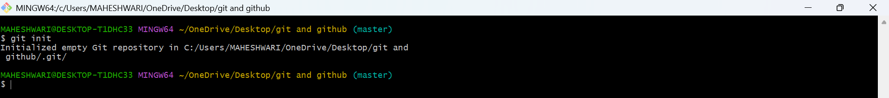
- git clone <repo_url>: Clones a repository from a remote
URL to your local machine.
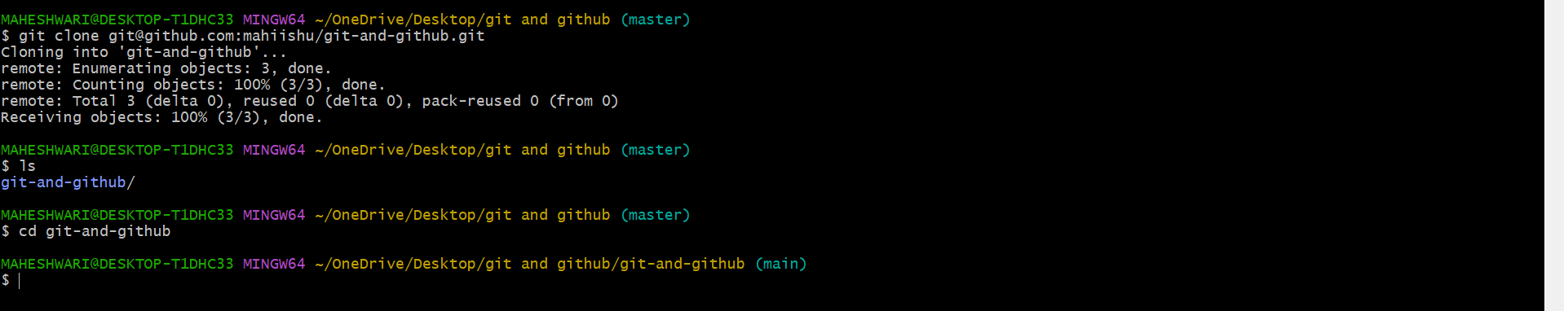
- git status: Shows the working directory status (which files are
modified, staged, etc.).
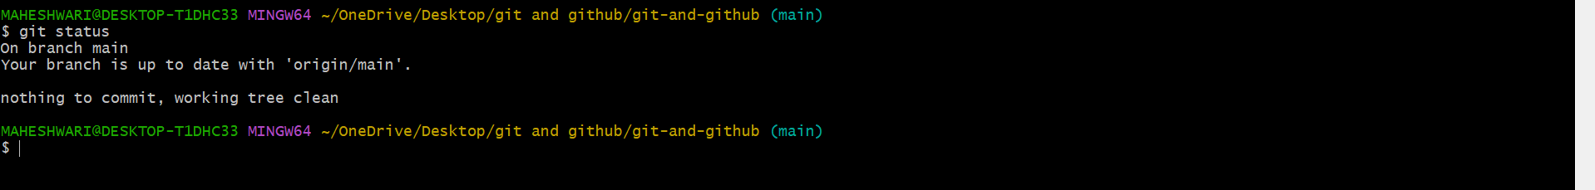
- git add : Stages a file or files to be committed.
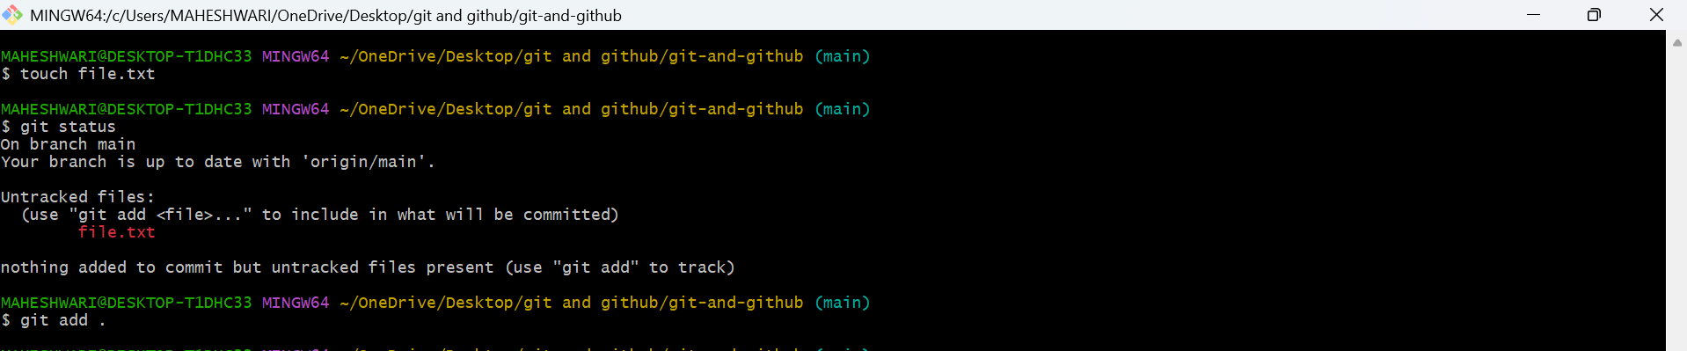
- git commit -m "message": Commits staged changes to the
local repository with a message.
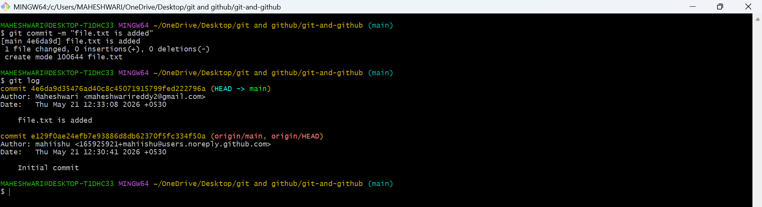
- git push: Pushes committed changes to the remote repository.
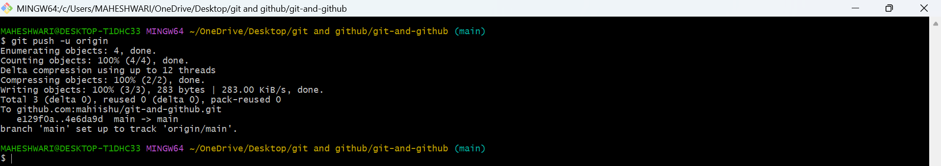

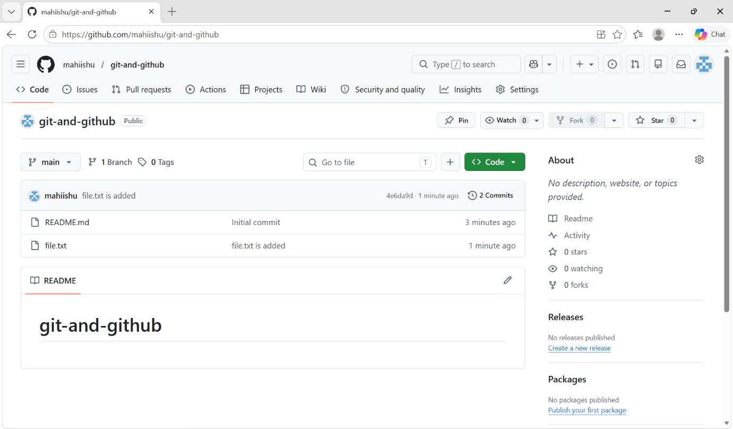

- git pull: Fetches and merges changes from the remote
repository to your local working directory.
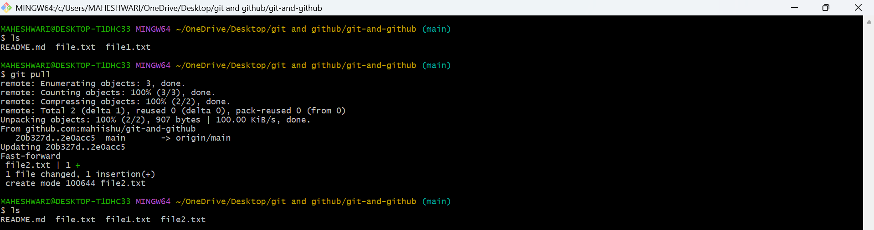
- git fetch: Downloads objects and refs from another repository
(without merging).
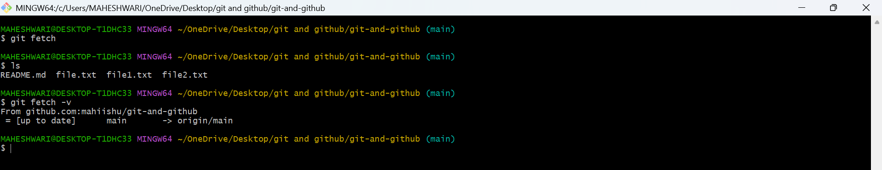
- git merge : Merges changes from the specified branch into the
current branch.
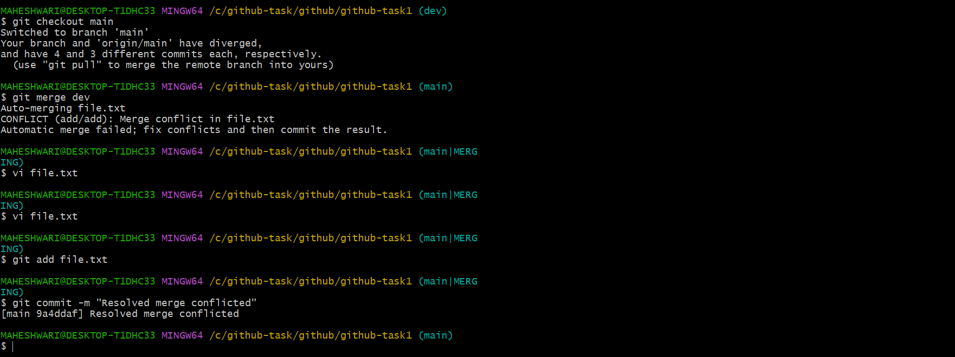

- git log: Shows the commit history of the repository.
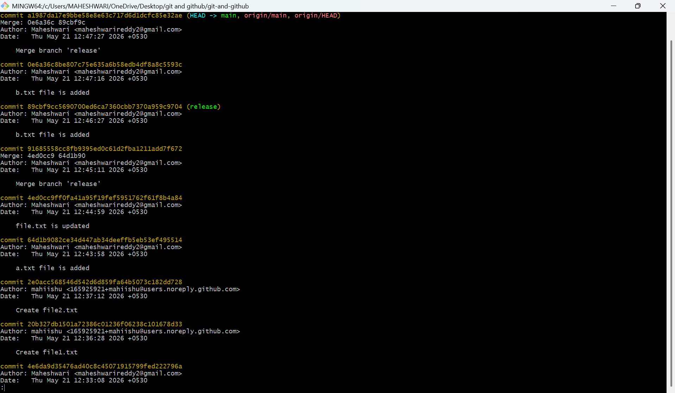

- git diff: Shows the differences between your working
directory and the index (staged changes).
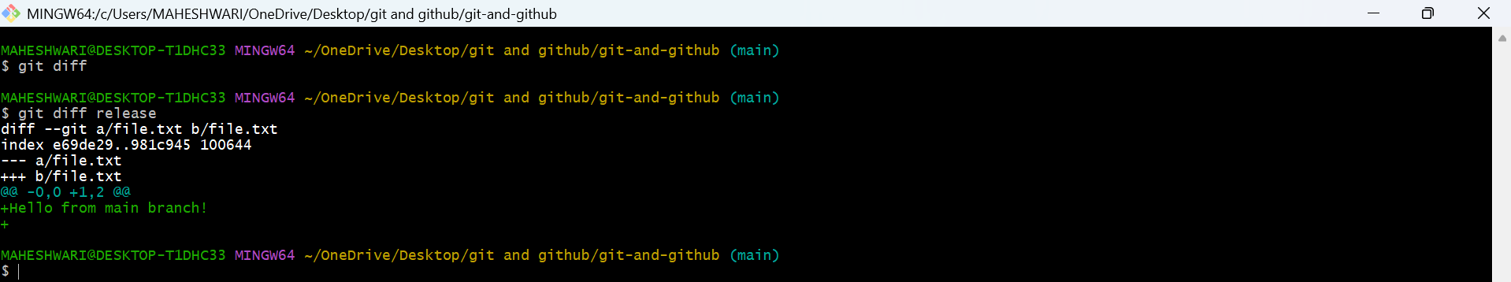

Branching Commands (Managing branches)
PURPOSE: isolation of work , parallel development, organized workflow
OBJECTIVE: This allows to work on separate features, bug fixes, or experiments without affecting the main codebase
- git branch: Lists all branches in your repository.
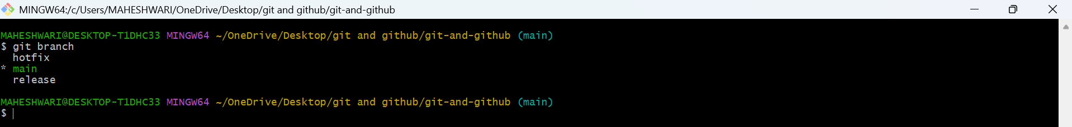
- git branch <branch_name>: Creates a new branch.
- git checkout <branch_name>: Switches to an existing
branch.
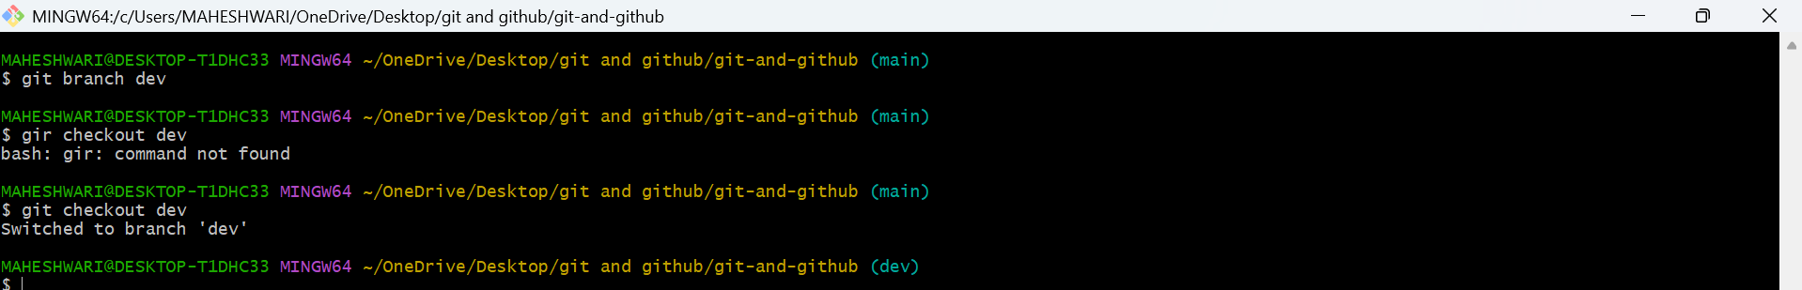
- git checkout -b <branch_name>: Creates and switches to a new branch in one step.
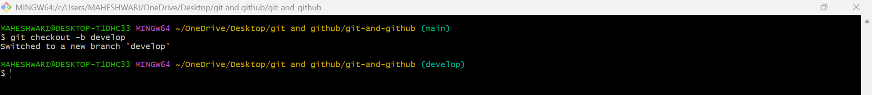
- git merge <branch_name>: Merges changes from the
specified branch into the current branch.
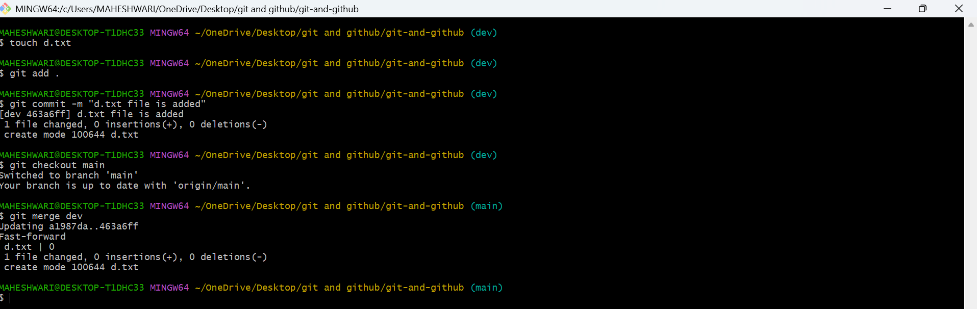
- git rebase <branch_name>: Applies changes from one
branch onto another branch (instead of merging).
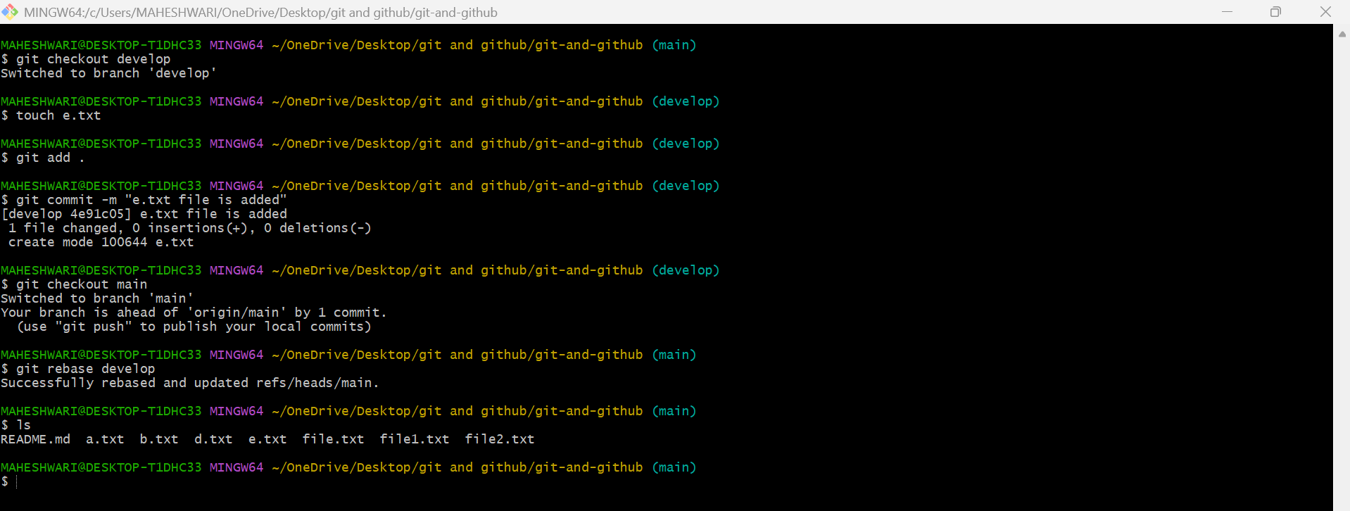
- git branch -d <branch_name>: Deletes the specified branch (locally).
- git branch -D <branch_name>: Forcefully deletes a branch (locally).
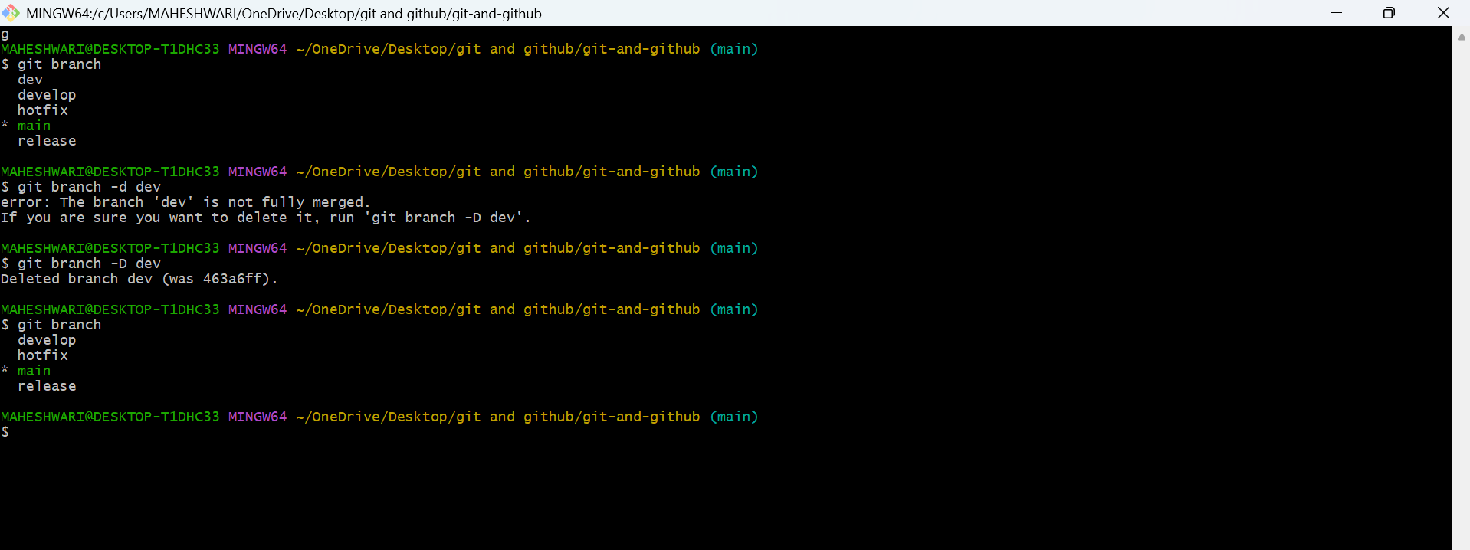

- git remote set-head origin <branch_name>: Sets the
default branch for the remote repository.
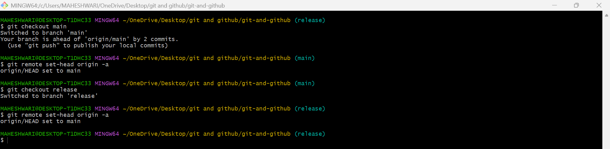

3. Remote Commands (Managing remotes and syncing with the cloud)
PURPOSE: The purpose of remote commands in github is to manage and interact with remote repo, which are hosted on platforms like GITHUB, GitLab, or your own server.
OBJECTIVE: To facilitate the management and collaboration of code repositories.
- git remote -v: Shows the remote repository URLs.
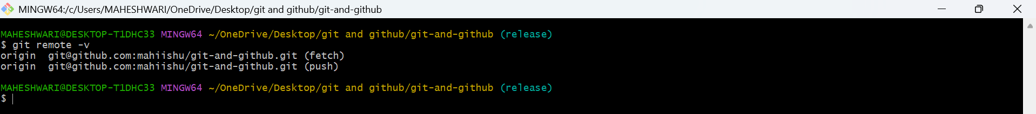

- git remote add : Adds a new remote repository.
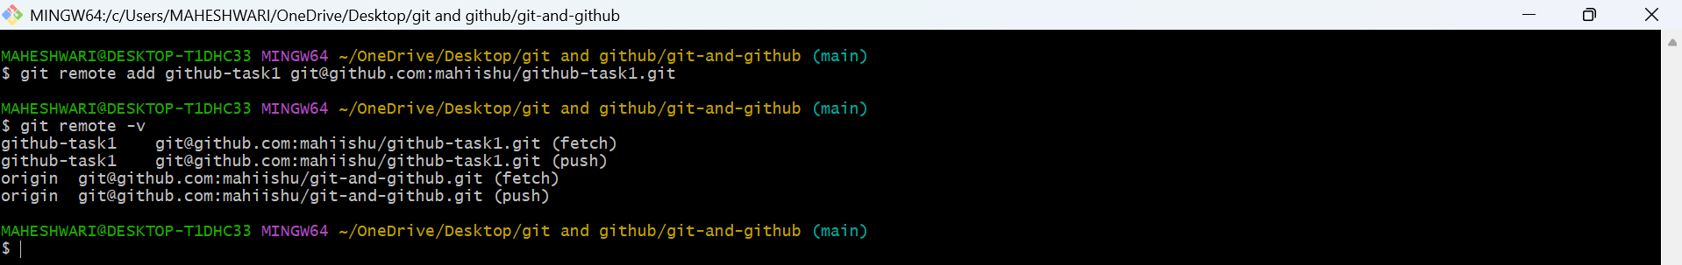
- git remote remove : Removes a remote repository.
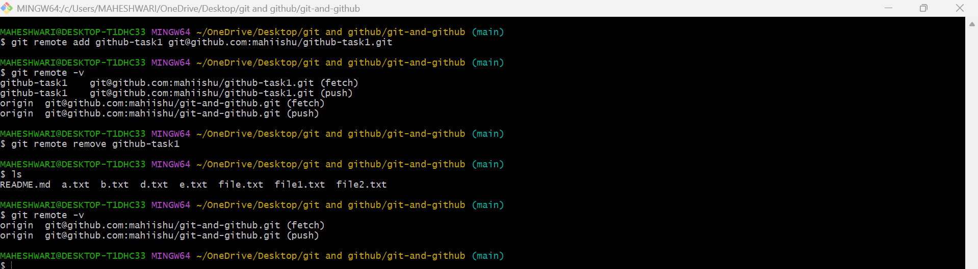
- git push origin <branch_name>: Pushes a branch to a remote repository.
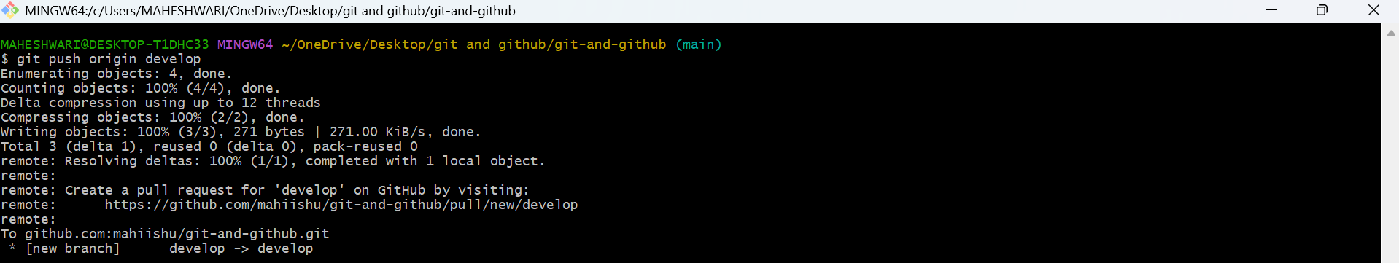
- git push -u origin <branch_name>: Pushes a branch to a remote repository and sets the upstream for the branch.
- git pull origin <branch_name>: Fetches and merges branch from the remote repository.
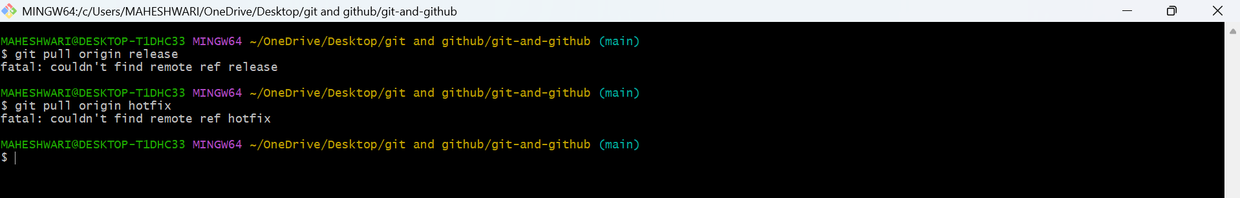

- git fetch origin: Downloads objects and refs from the remote repository.
- git remote show origin: Displays detailed information about a remote repository.
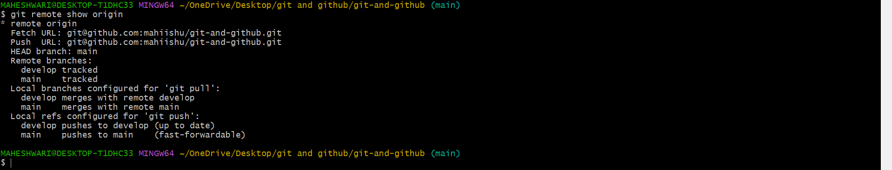

4. Staging and Committing (Managing changes)
PURPOSE: preparing changes in the staging area before committing them to the repo.
OBJECTIVE: this allows you to control exactly which changes go into your next commit.
- git add . : Stages all modified files in the working directory.
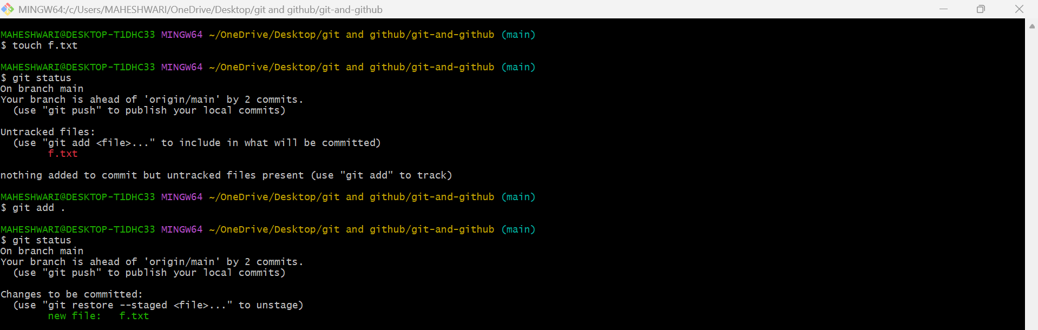
- git add -A: Stages all modified files (including file deletions).
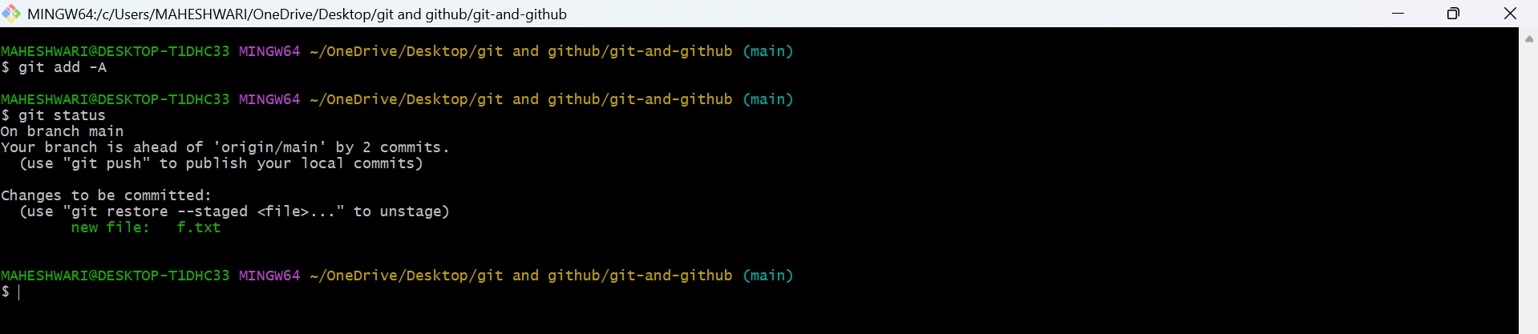
- git reset : Unstages a file (reverts it to the working directory).
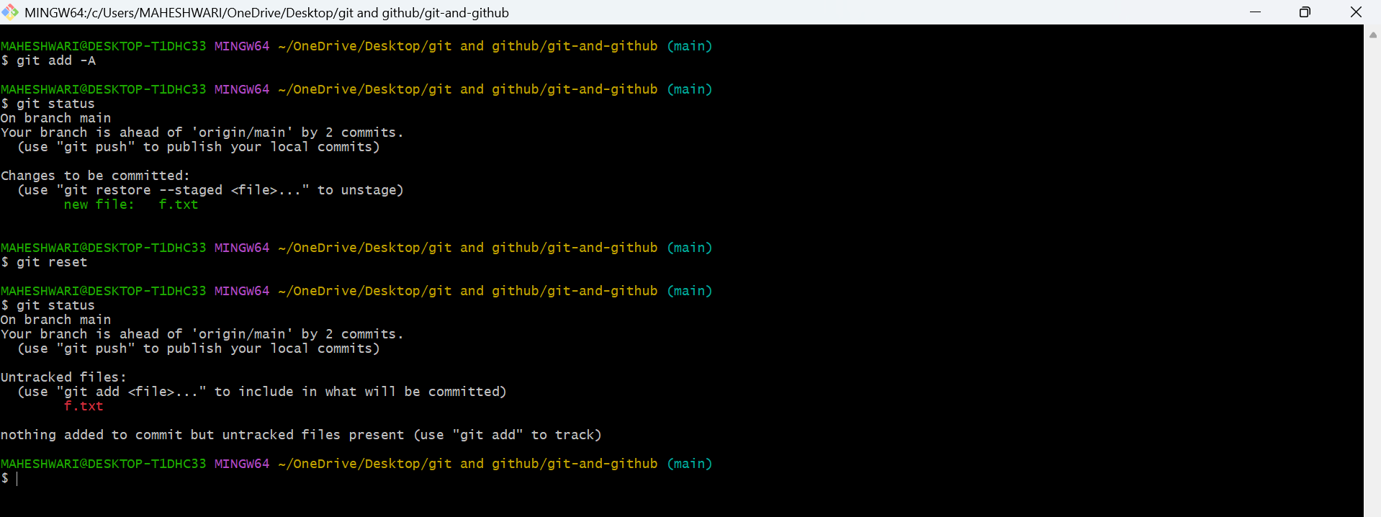
- git commit --amend: Modifies the last commit (can change the commit message or add changes).
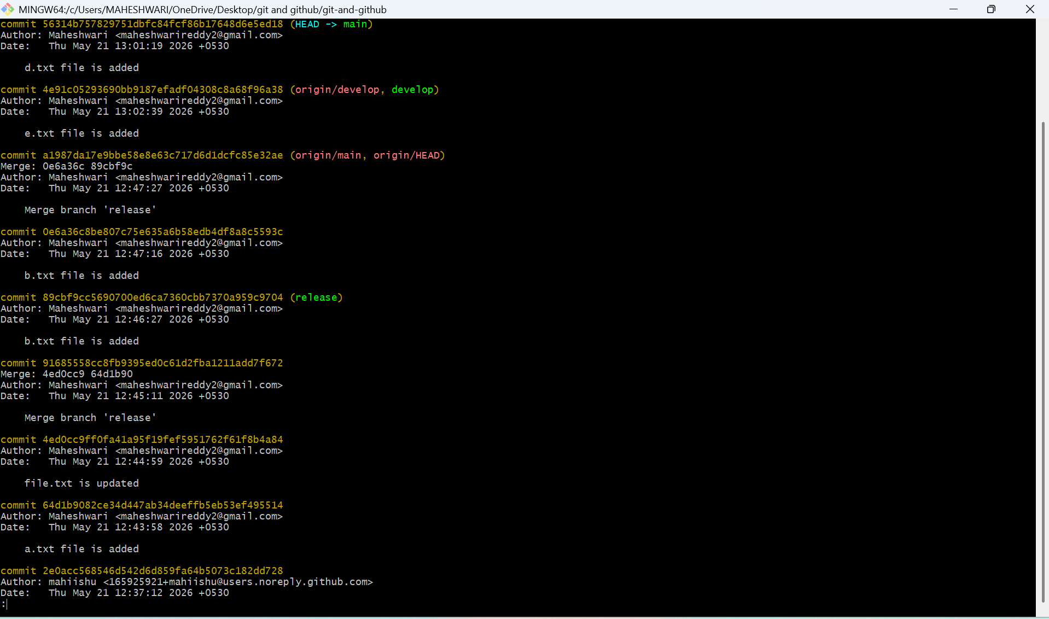
- git commit --all: Automatically stages tracked files and commits them.
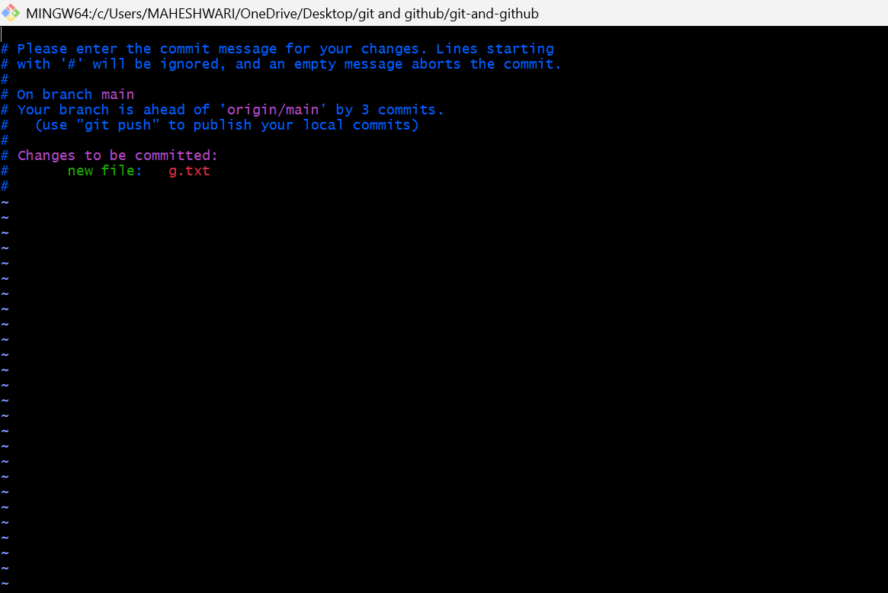
- git commit -a: Stages and commits all modified files.
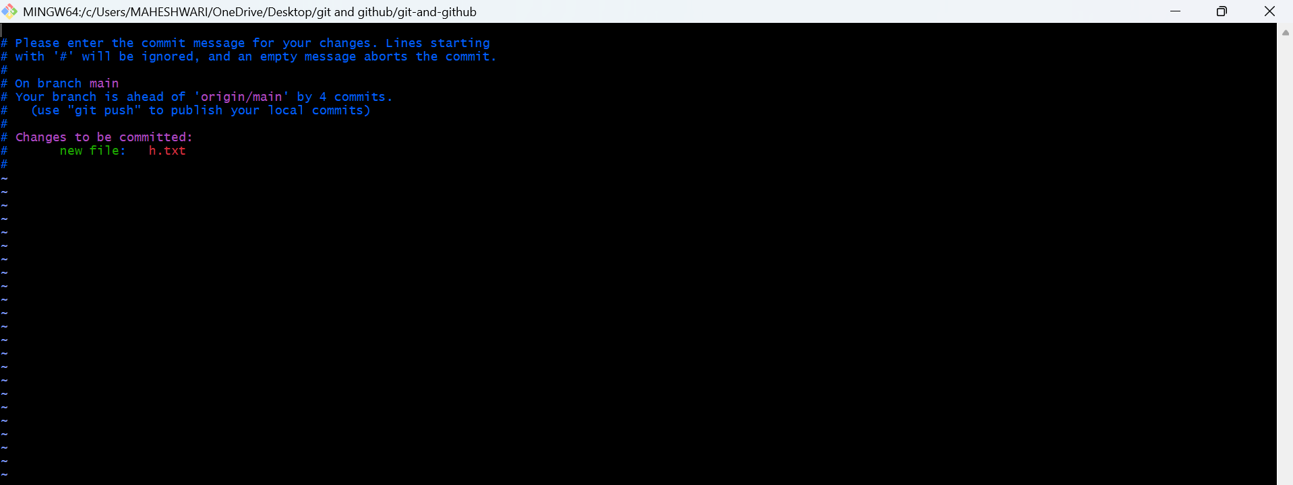
- git commit --no-verify: Skips pre-commit hooks while
committing.
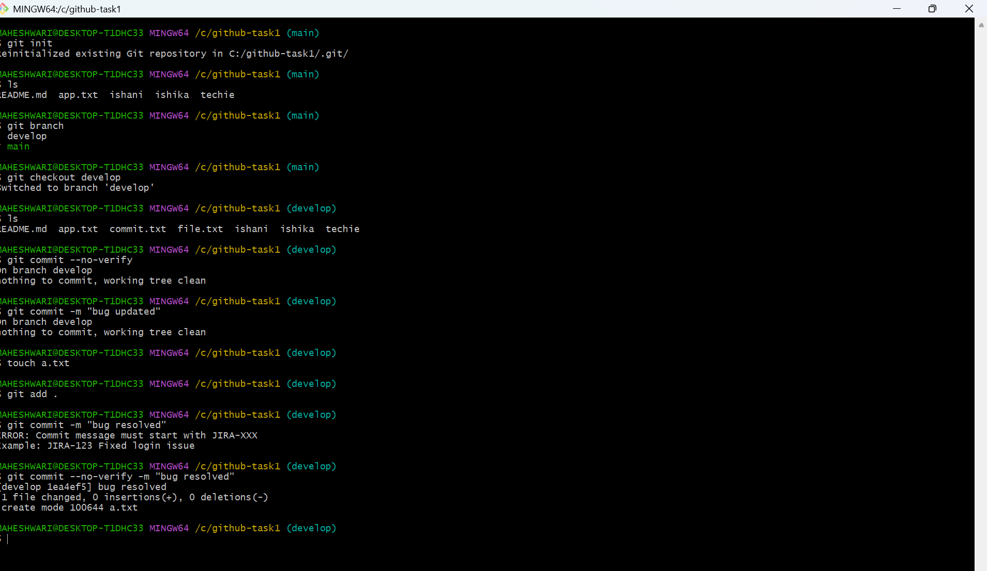
- git reset --soft HEAD~1: Moves the HEAD pointer back
one commit but leaves your changes staged.
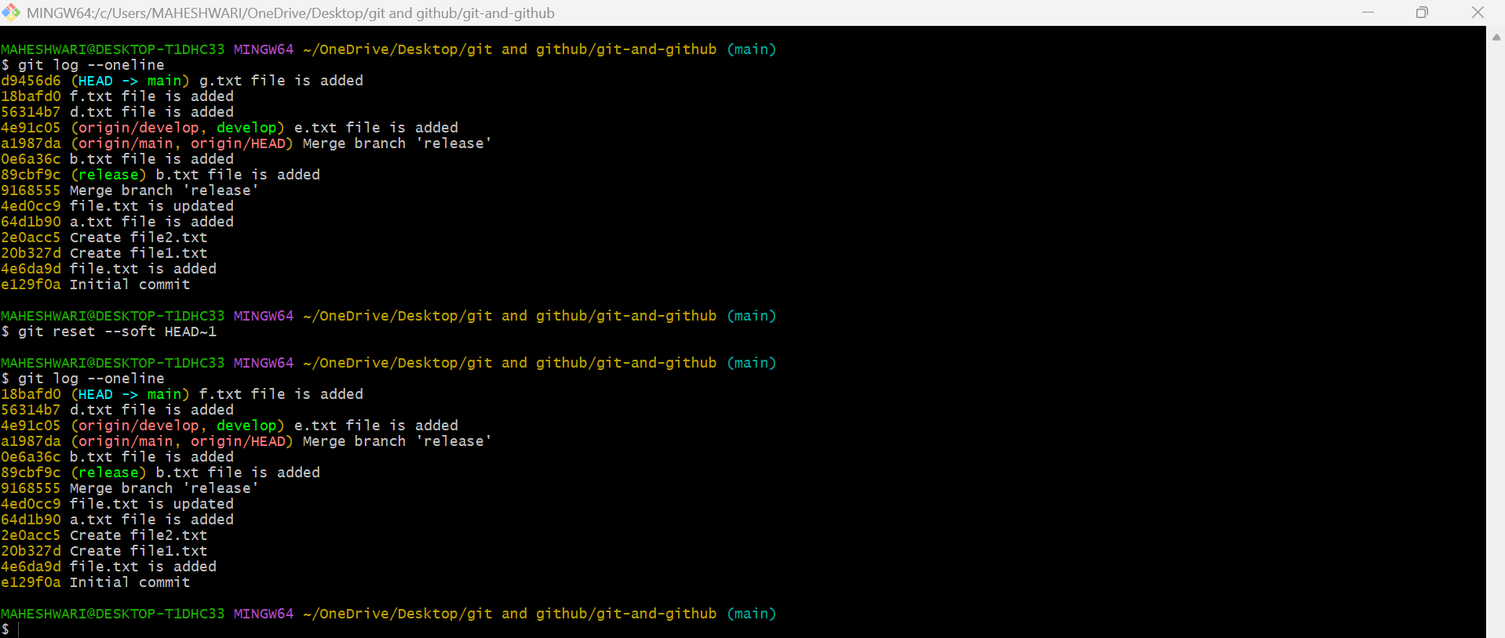
- git reset --hard HEAD~1: Moves the HEAD pointer back
one commit and discards changes in the working directory.
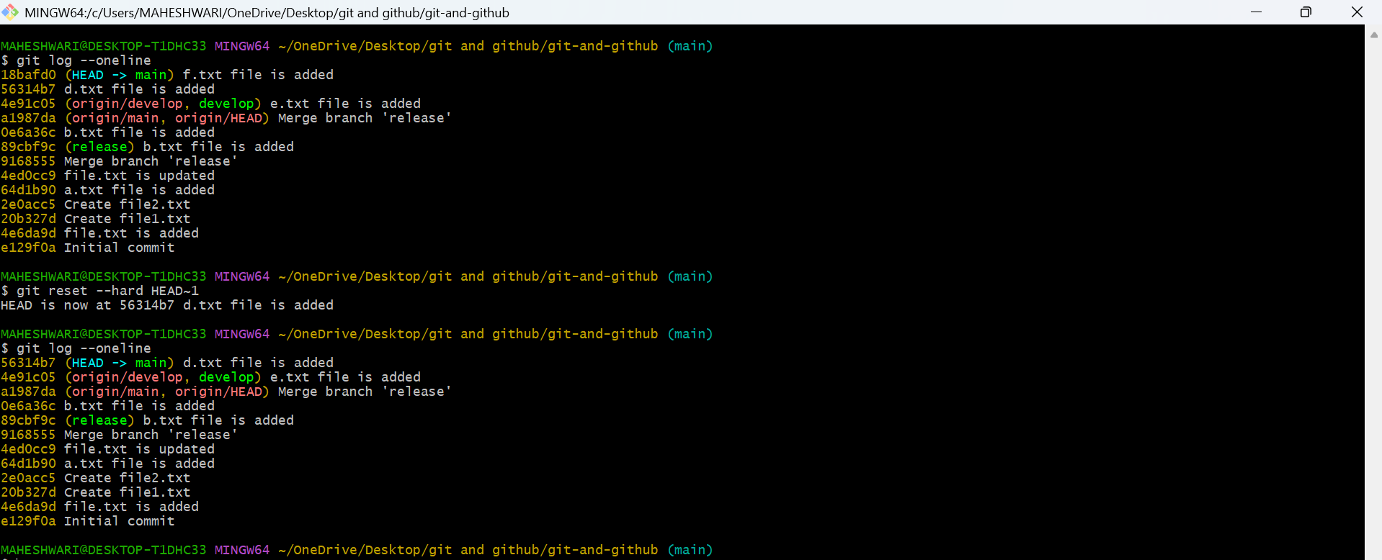

5. Viewing and Comparing Changes (Inspecting changes)
PURPOSE: crucial for understanding what was added, modified, or removed in a specific commit.
OBJECTIVE: To provide developers with the ability to review and understand the modifications made to their code.
- git diff: Shows changes between your working directory and the index (unstaged changes).
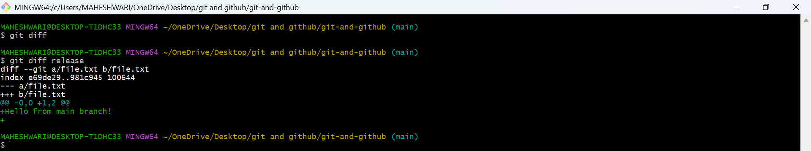
- git diff --staged: Shows changes between the index (staged files) and the last commit.
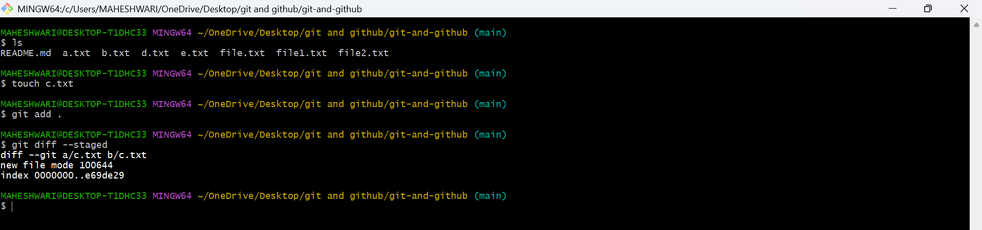
- git diff <commit_id>: Shows the differences between your working directory and a specific commit.
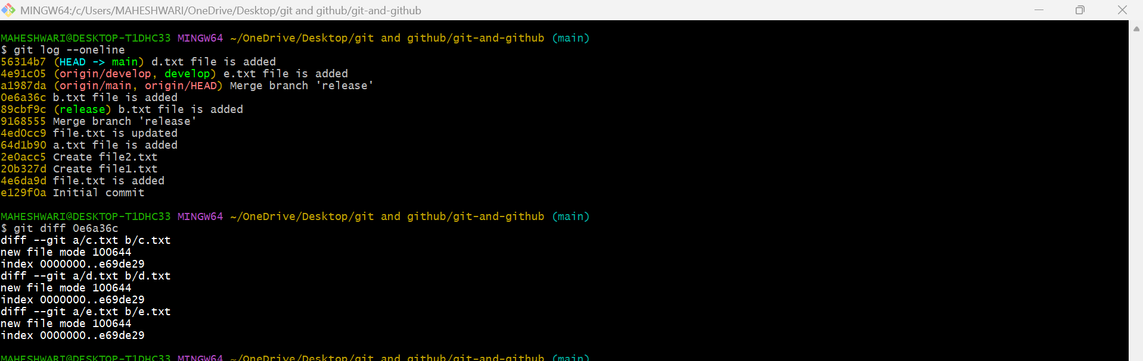
- git log: Displays the commit history.
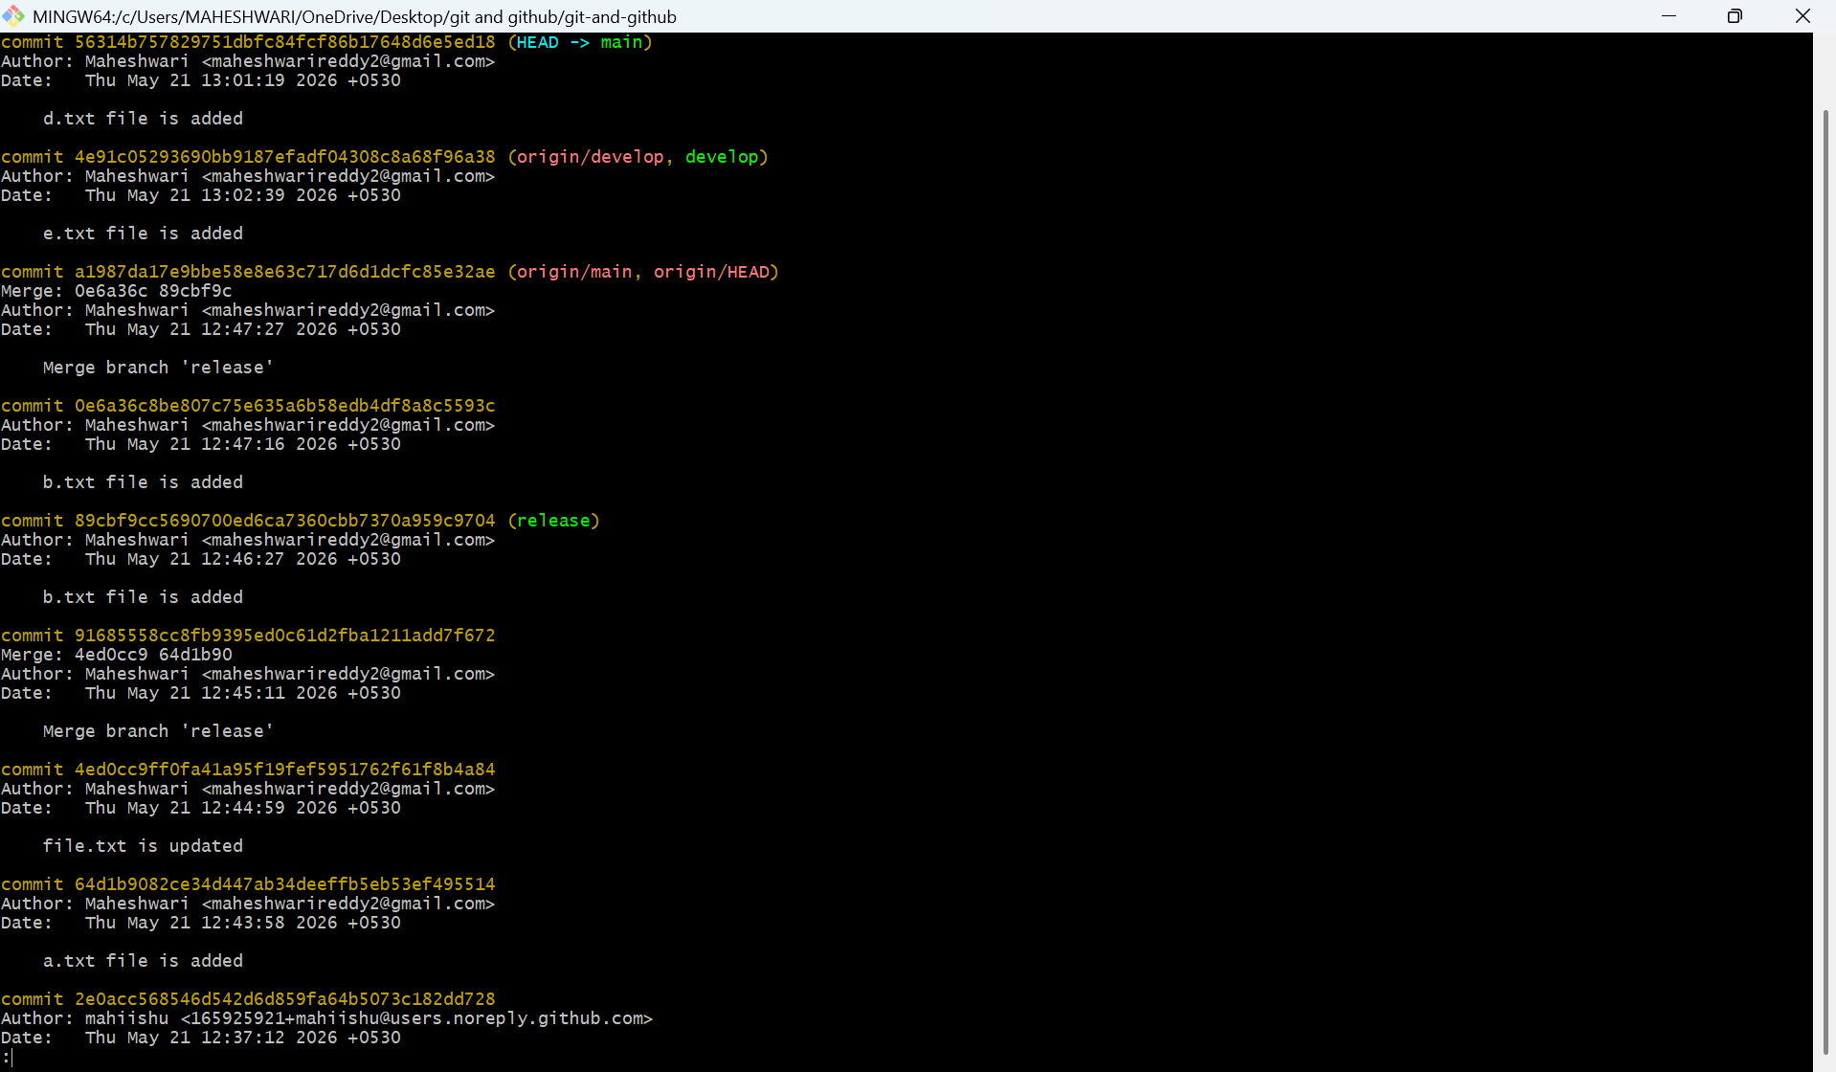
- git log --oneline: Displays the commit history in a simplified one-line format.
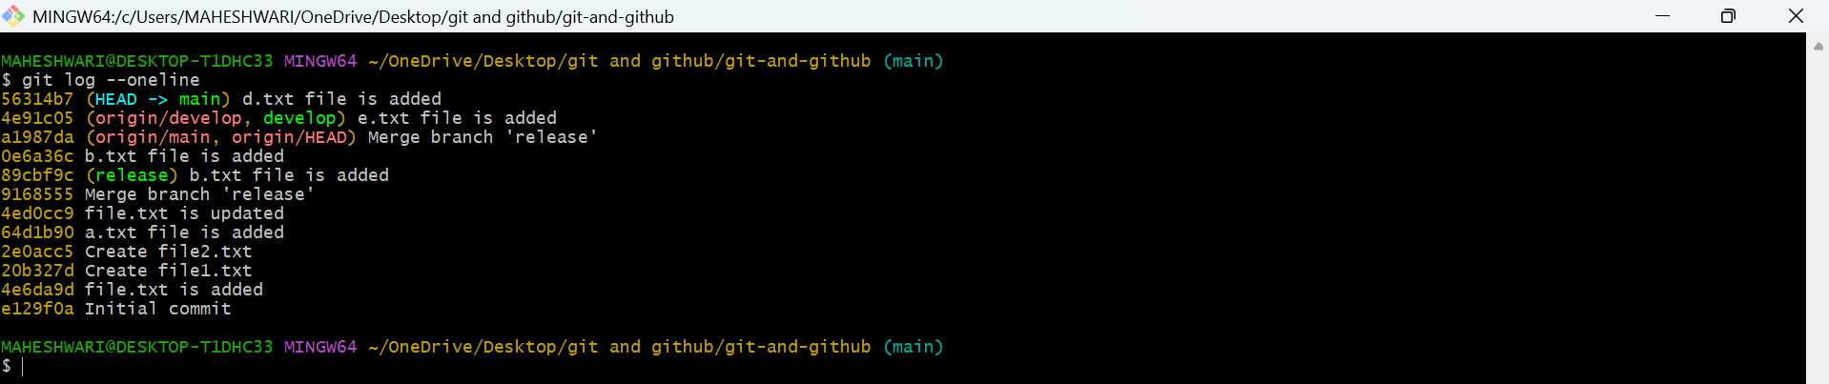
- git log --graph: Displays the commit history as a graph.
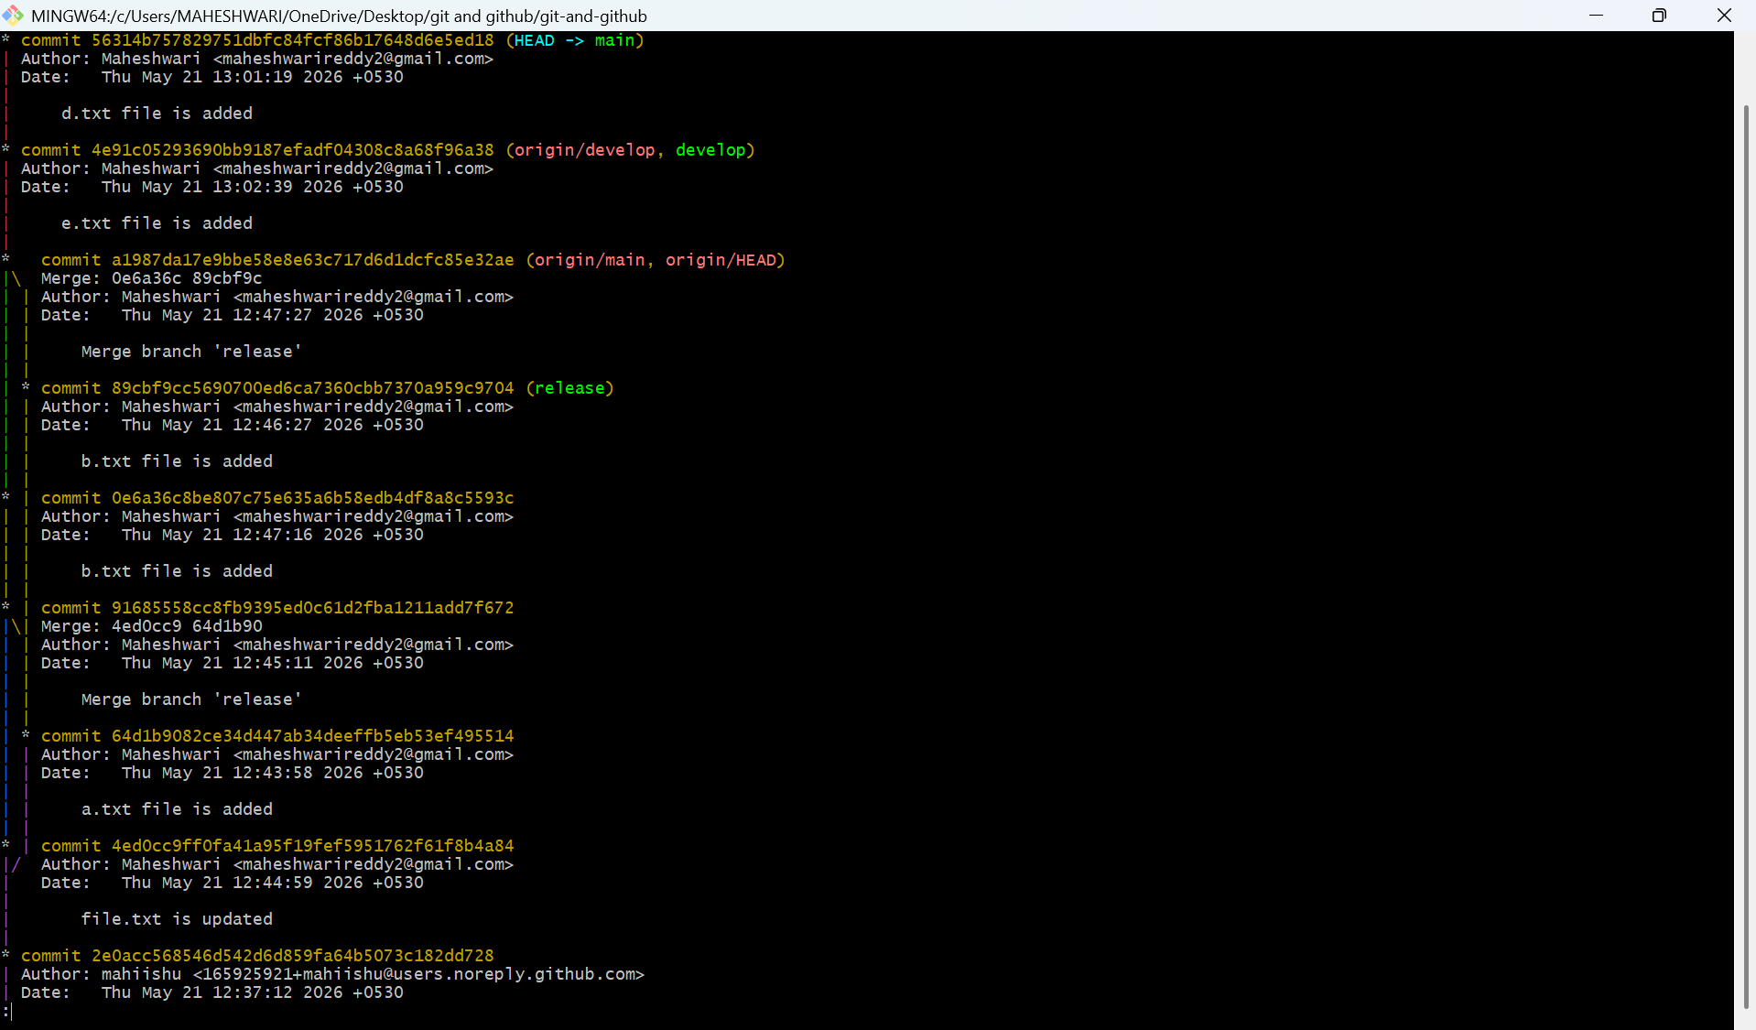
- git log --author="name": Filters commits by a specific
author.
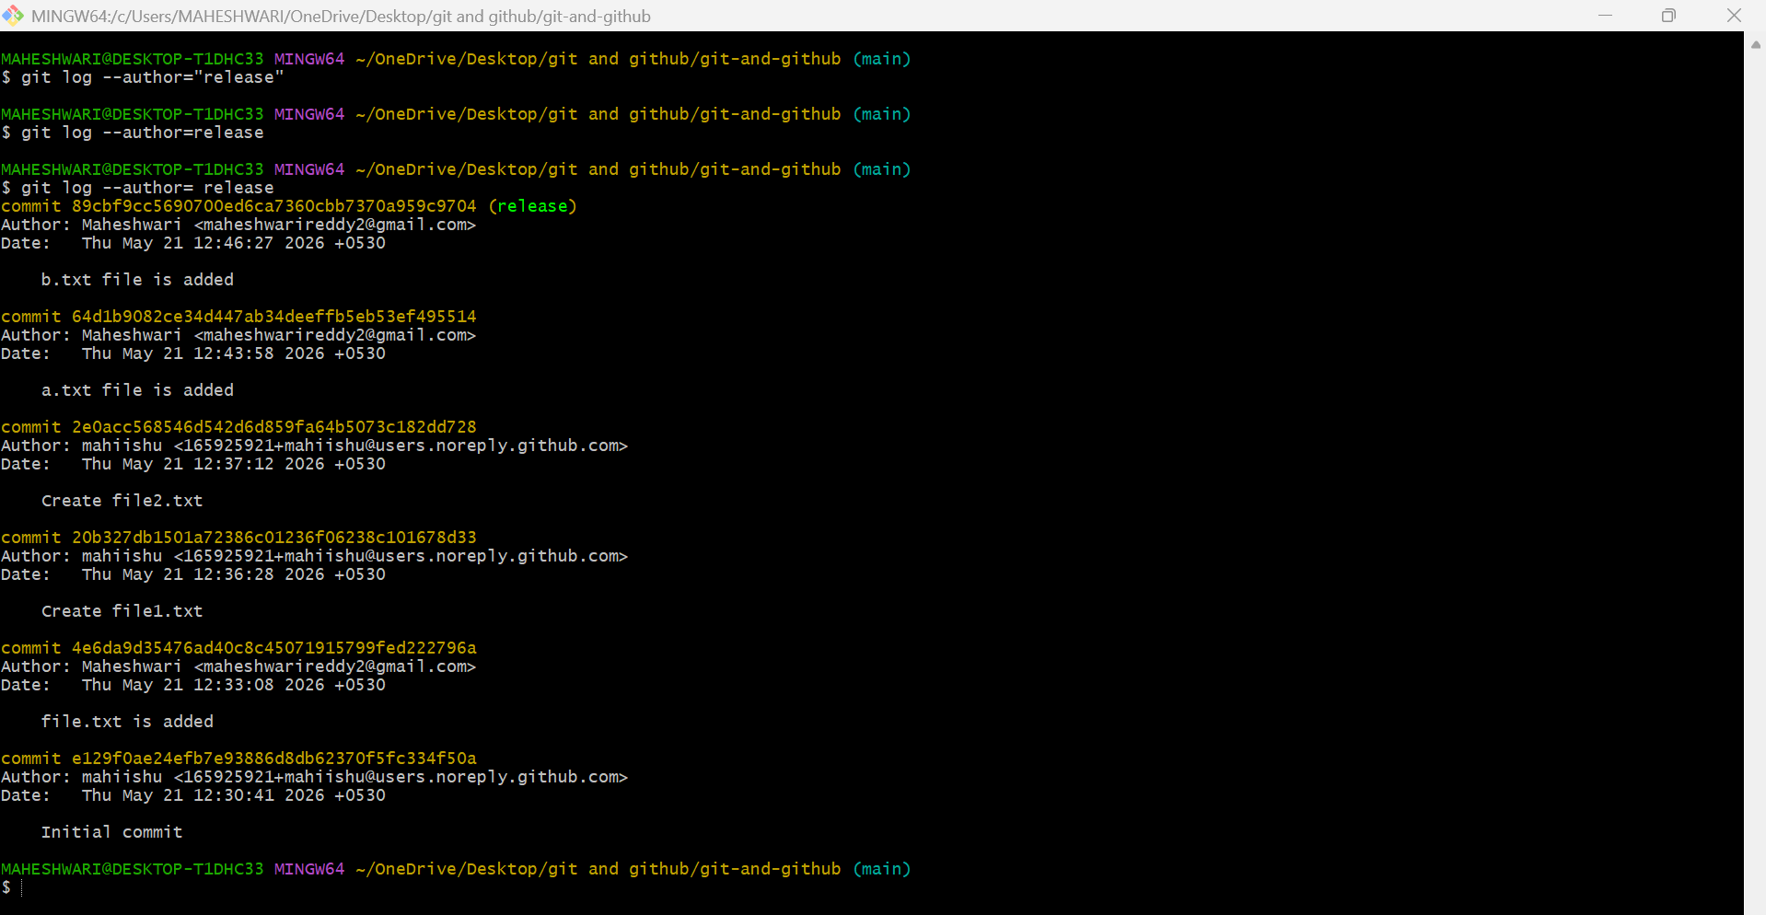
- git log --since="2 weeks ago": Filters commits made
after a specific date.
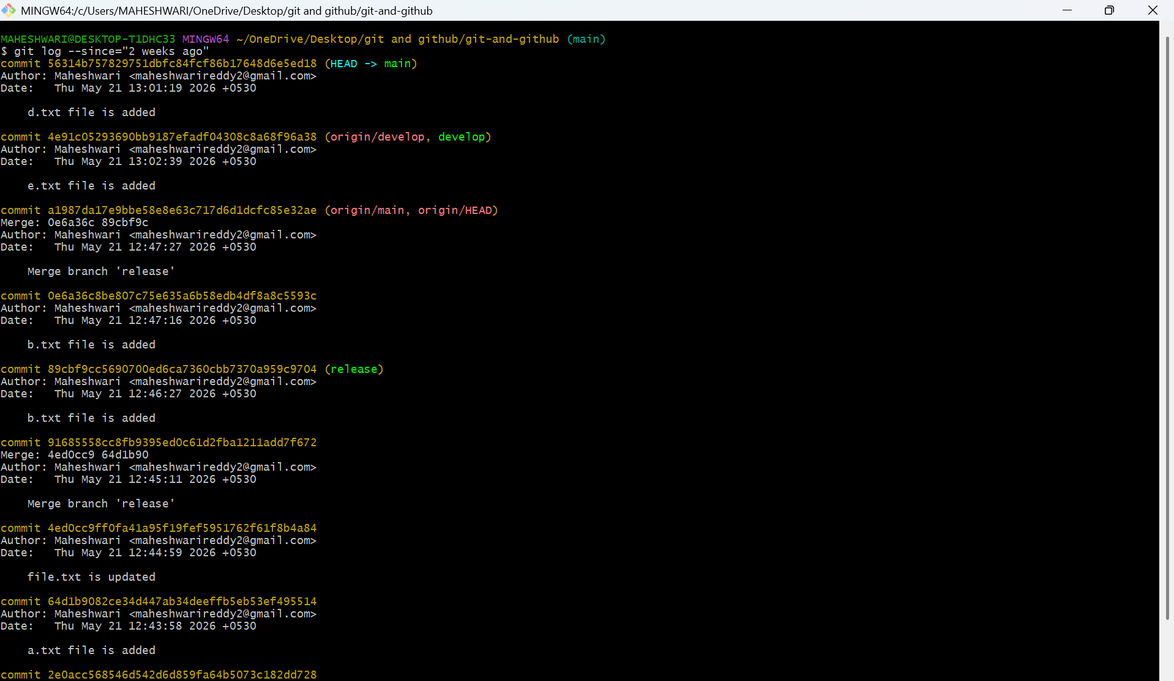
- git blame : Shows line-by-line annotations for a file, telling who last modified each line.
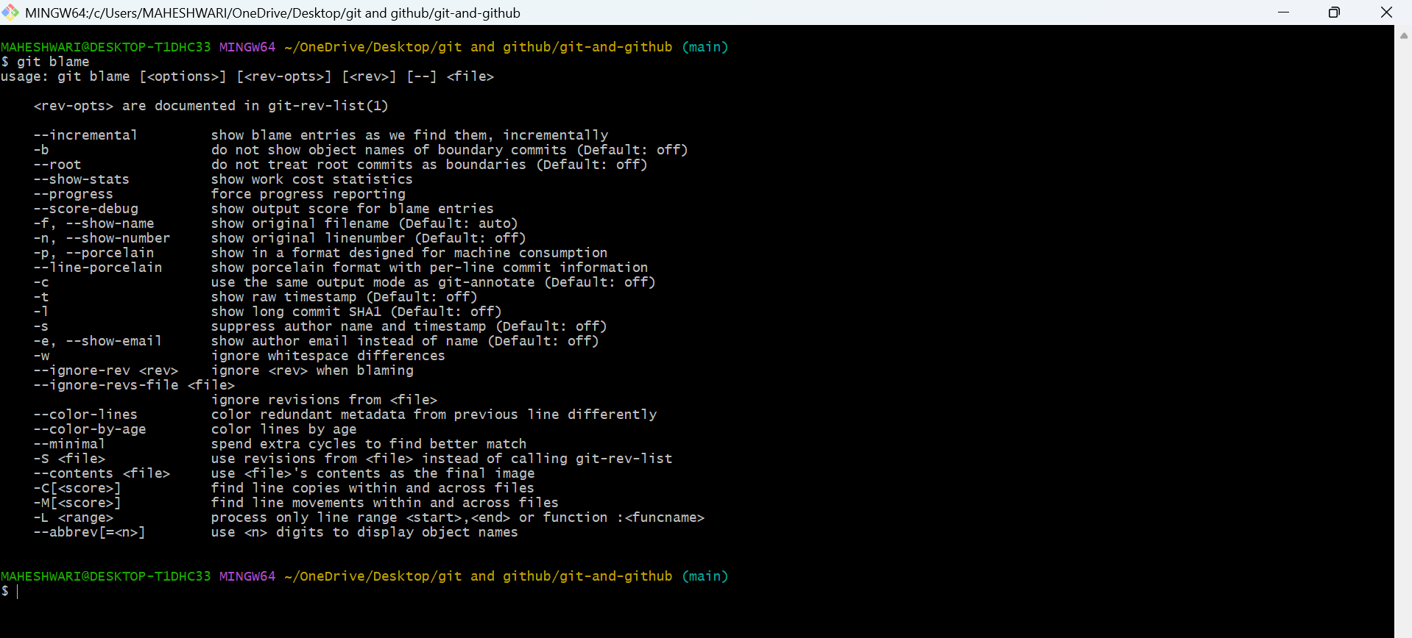
- git show <commit_id>: Shows details of a specific commit (including diff and metadata).
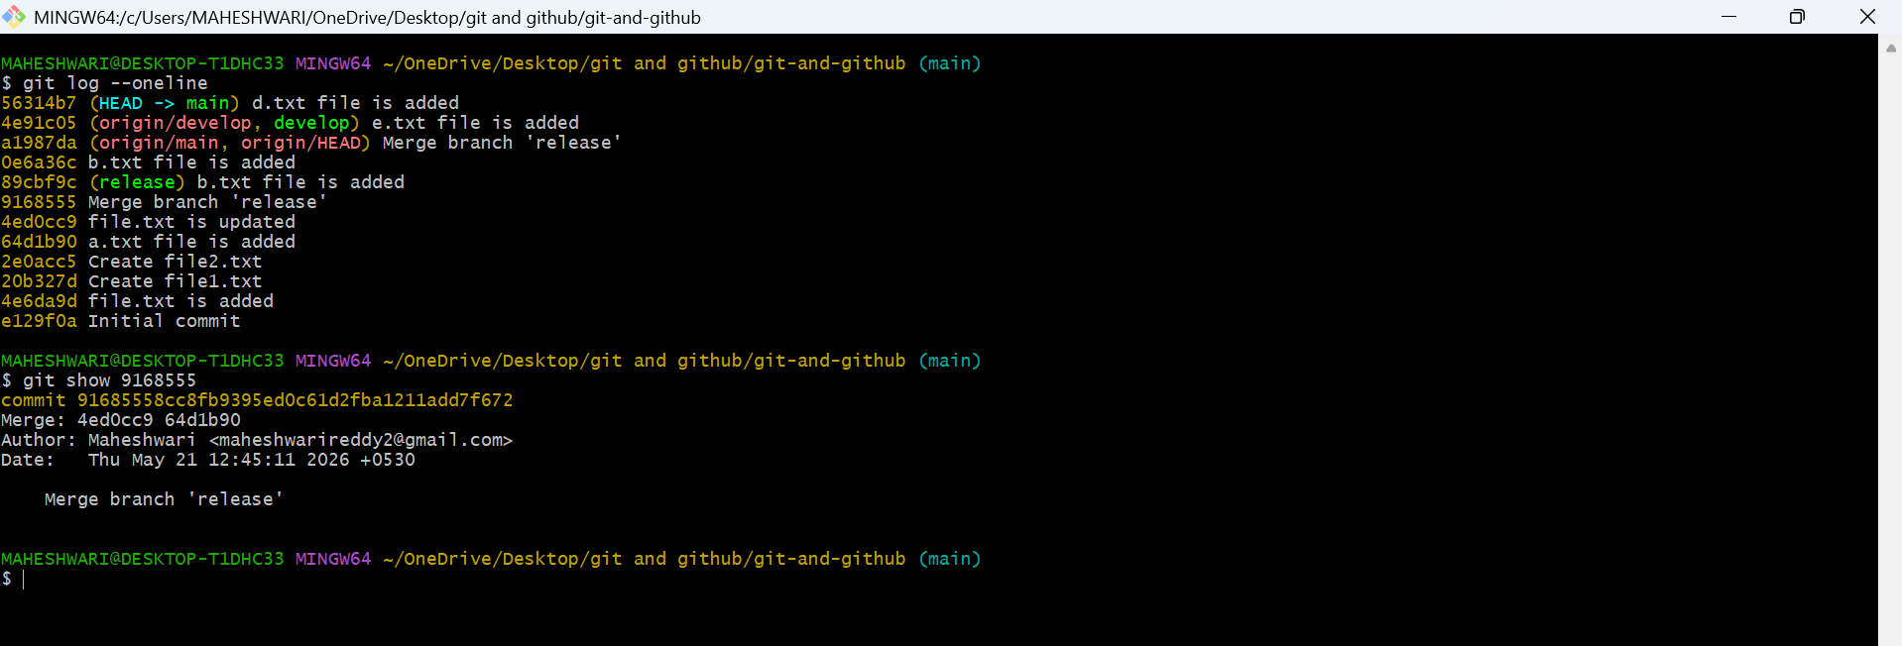
- git show <commit_id>:<file_path>: Shows a specific file at a particular commit.
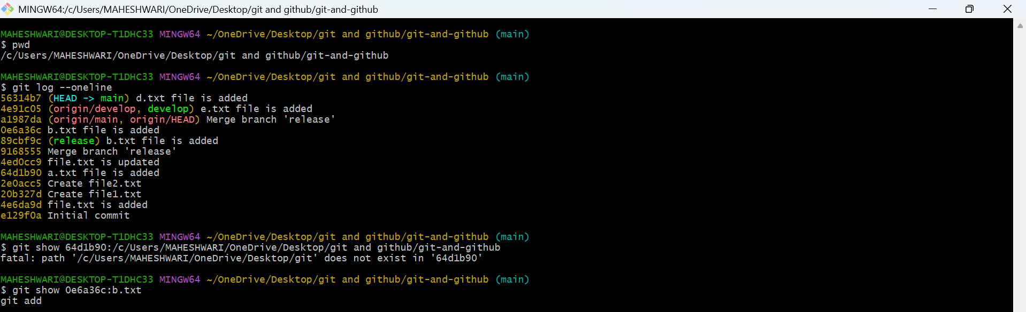

6. Reverting and Resetting (Undoing changes)
PURPOSE: git revert creates a new commit that undoes a previous commit while git reset moves pointer to a different commit, potentially altering commit history
OBJECTIVE: git revert command preserves the commit history, allowing for a clean and clear record of changes made. Whereas, git reset useful when you want to remove all changes made after that one specific commit, and restore the repo to that point.
- git reset <commit_id>: Moves HEAD to a specific commit, leaving your working directory intact (can be used with --soft, --mixed, or --hard).
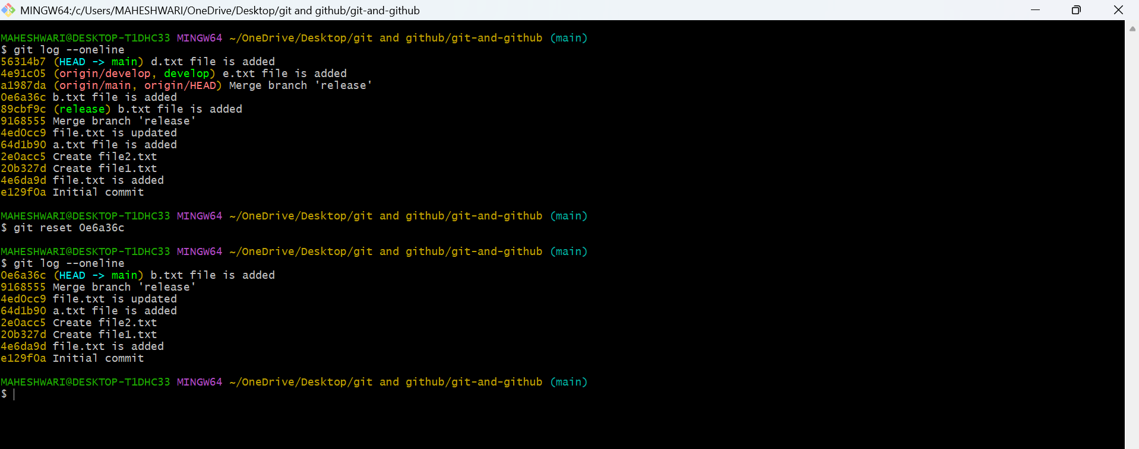
- git reset --hard <commit_id>: Resets your working directory, index, and HEAD to a specific commit (all changes will be lost).
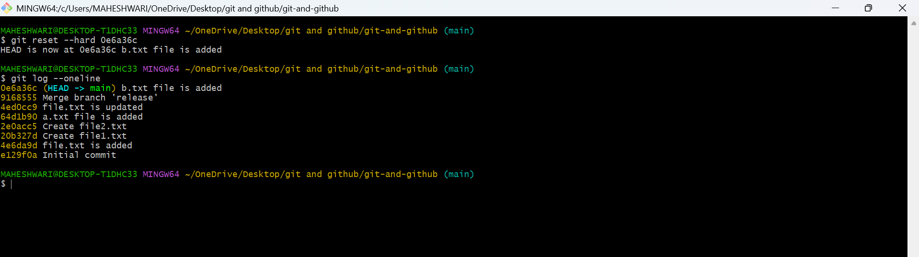
- git reset --soft <commit_id>: Resets only the HEAD to a
specific commit, leaving staged changes.
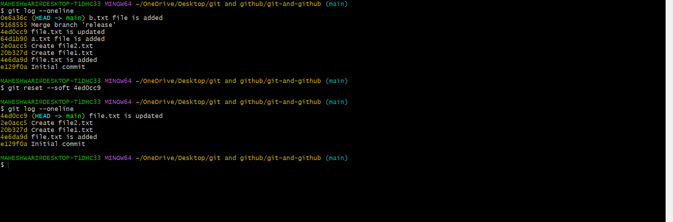
- git reset --mixed <commit_id>: Resets the HEAD and
index to a specific commit but keeps the working directory unchanged.
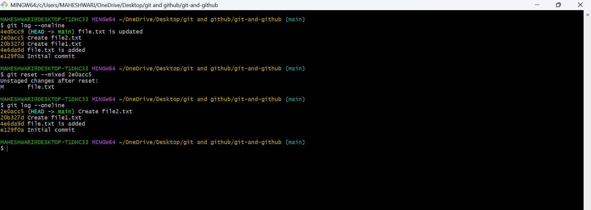
- git revert <commit_id>: Creates a new commit that undoes the changes of the specified commit.
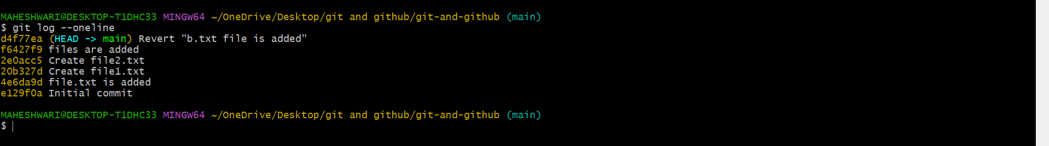

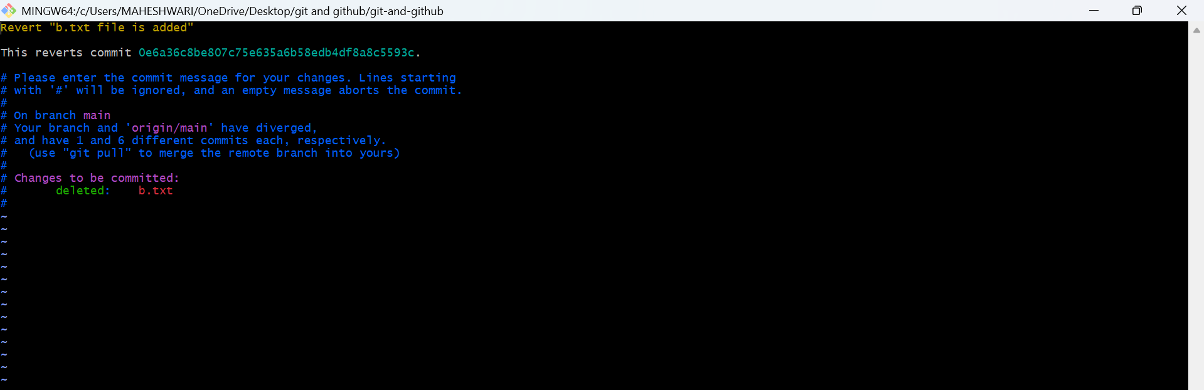

- git restore : Restores the file(s) in the working directory from the index or a commit.
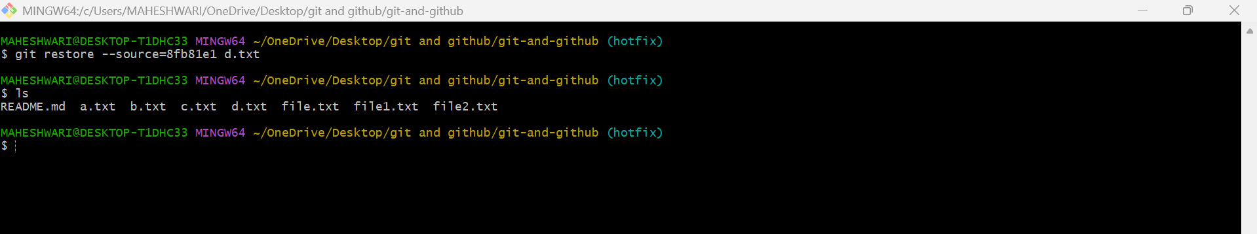
- git restore --staged : Removes a file from the staging
area.
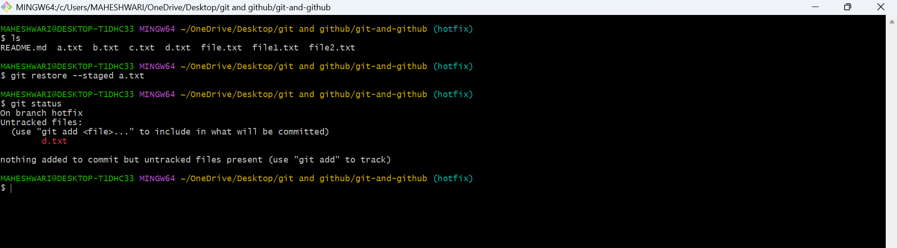
- git clean -f: Removes untracked files in the working directory.
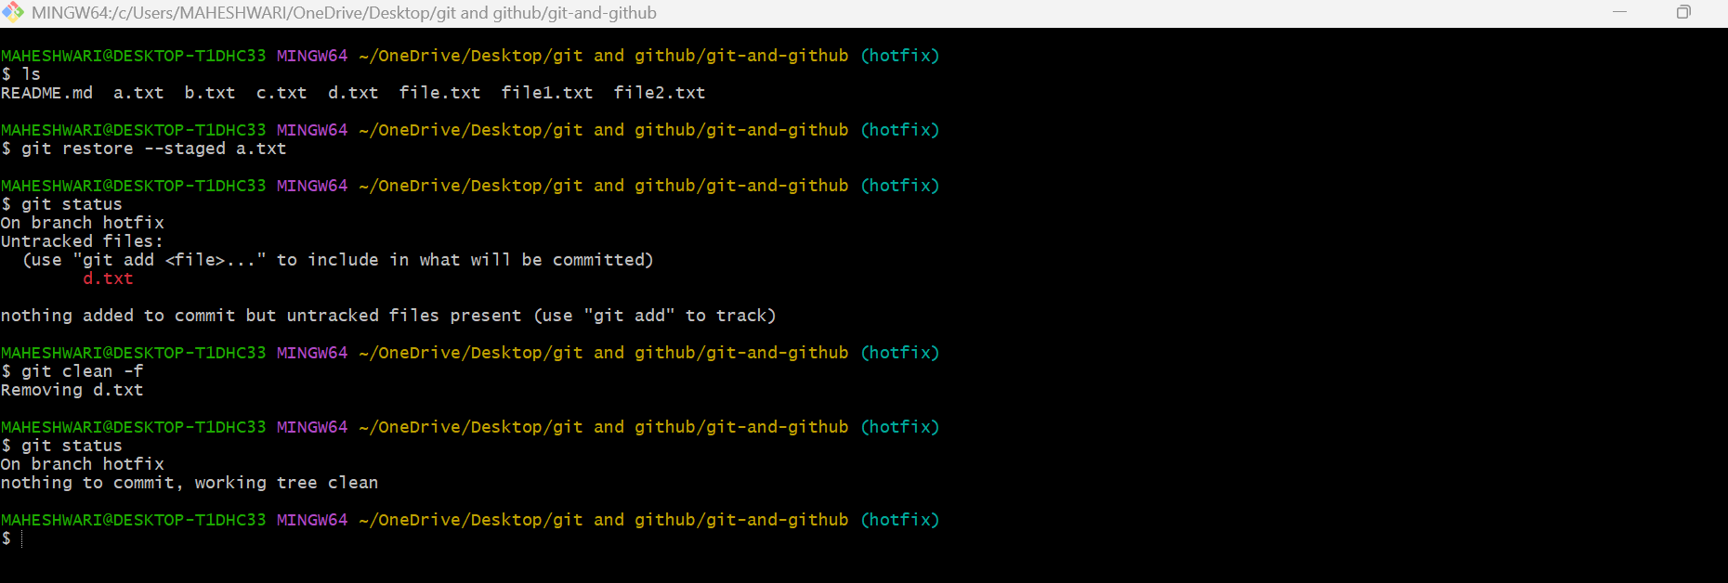
- git clean -fd: Removes untracked files and directories

7. Stashing (Temporarily saving changes)
PURPOSE: used to save your uncommitted changes and return to a clean working directory.
KEY OBJECTIVES: Temporary saving, keeping commit history clean, handling urgent work, selective stashing and managing changes.
- git stash: Stashes the changes in your working directory (both staged and unstaged).
- git stash list: Lists all the stashes.
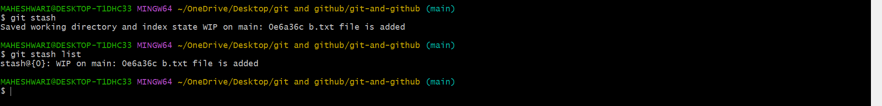
- git stash pop: Applies the latest stash and removes it from the stash list.
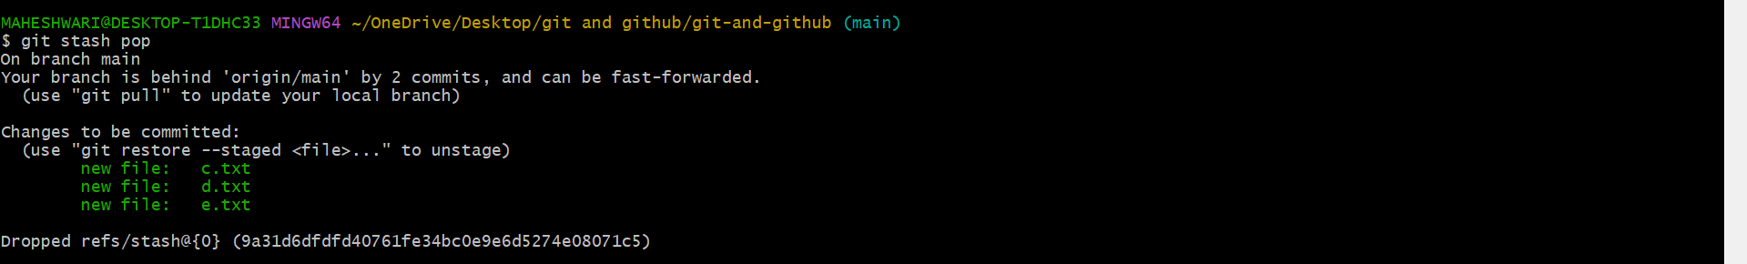
- git stash apply: Applies a stash without removing it from the list.
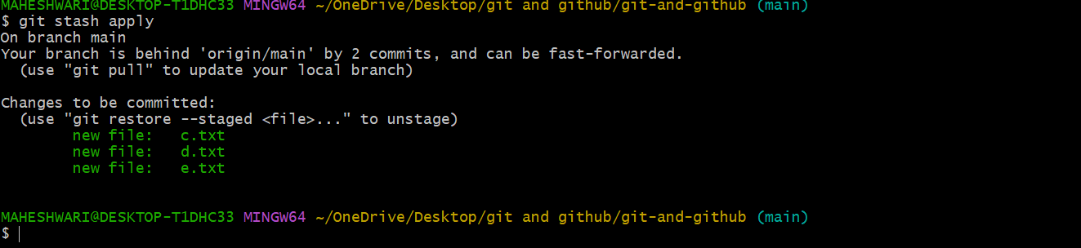
- git stash drop: Removes a specific stash from the stash list.
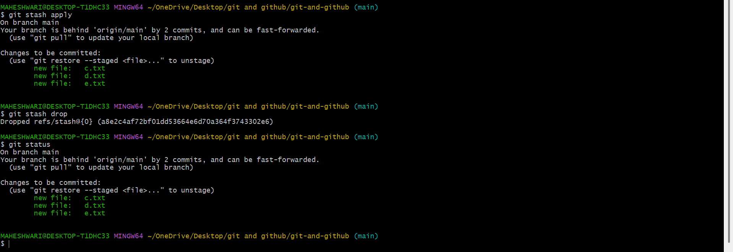
- git stash clear: Clears all stashes.
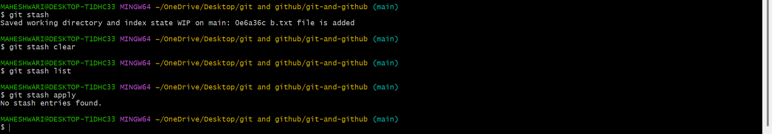
- git stash save "message": Stashes changes with an
optional message for identification.
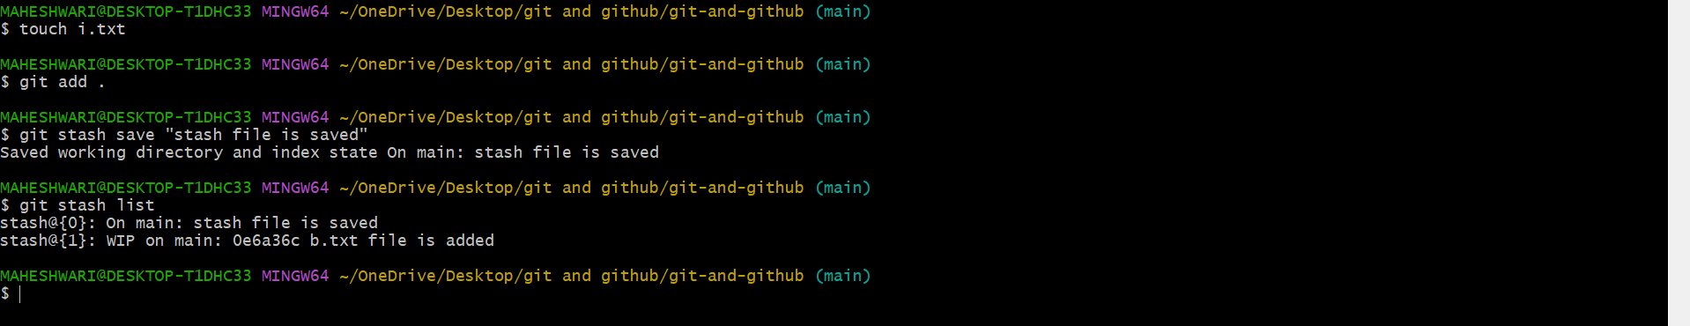
- git stash branch <branch_name>: Creates a new branch from the stash and applies it.
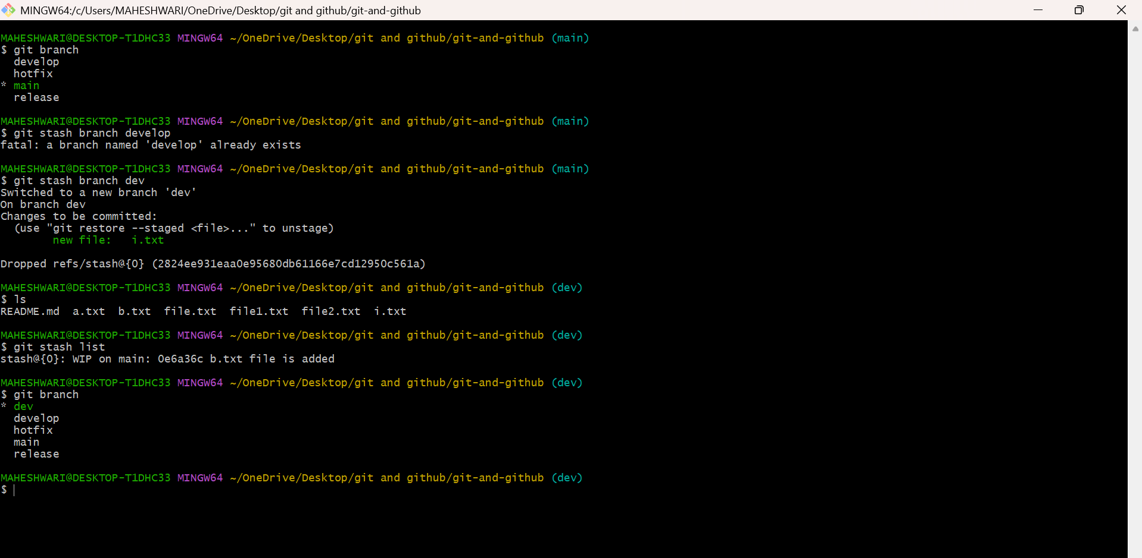

8. Tags (Managing versions)
PURPOSE: Tag is a reference to a specific commit, often used to mark important points in a project’s history such as releases, milestones or deployment versions.
->An END tag typically use to mark a stable or significant build for testing, deployment or release management.
TYPES OF TAGS:
1.light-weight tag: A simple pointer to a commit with no extra metadata
2.Annotated tag: stores the tagger’s name, email, date and a messege. Recommended for releases.
- git tag: Lists all tags in the repository.
- git tag <tag_name>: Creates a new tag at the current
commit.
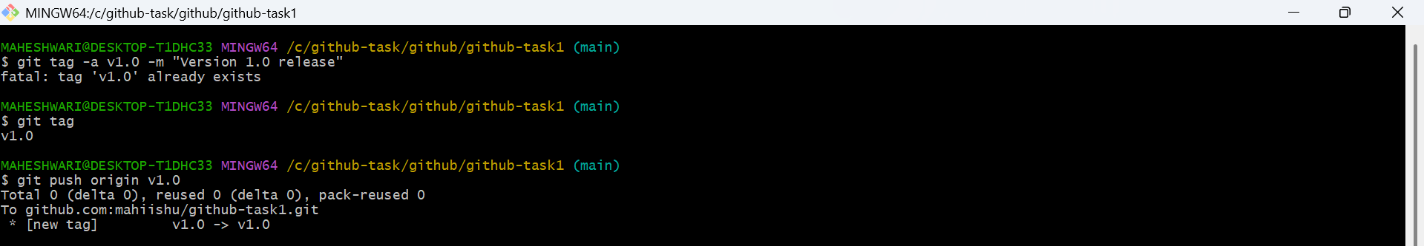

- git tag -a <tag_name> -m "message": Creates an
annotated tag with a message.
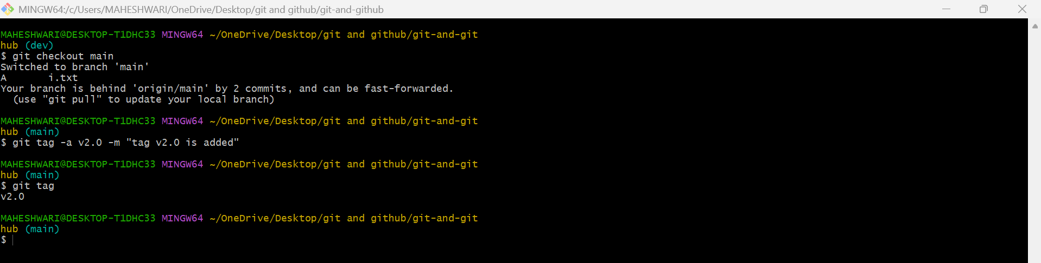
- git tag -d <tag_name>: Deletes a tag locally.
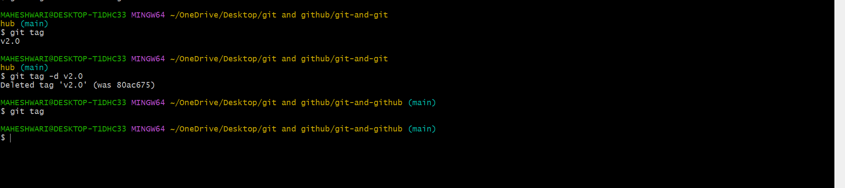
- git push origin <tag_name>: Pushes a specific tag to the remote repository.
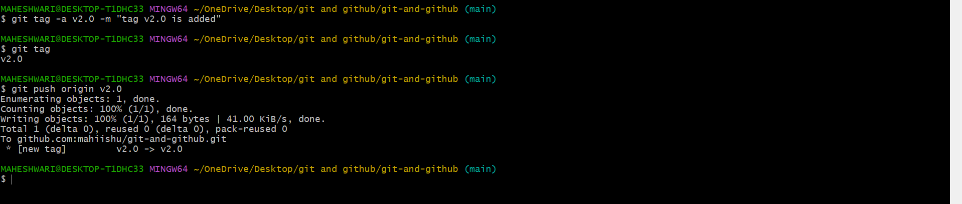
- git push origin --tags: Pushes all tags to the remote
repository.
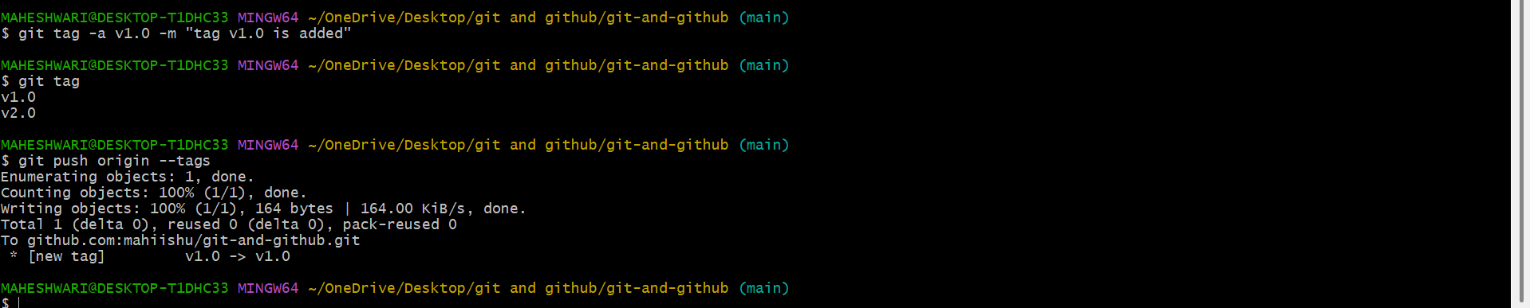
- git fetch --tags: Fetches all tags from the remote
repository.
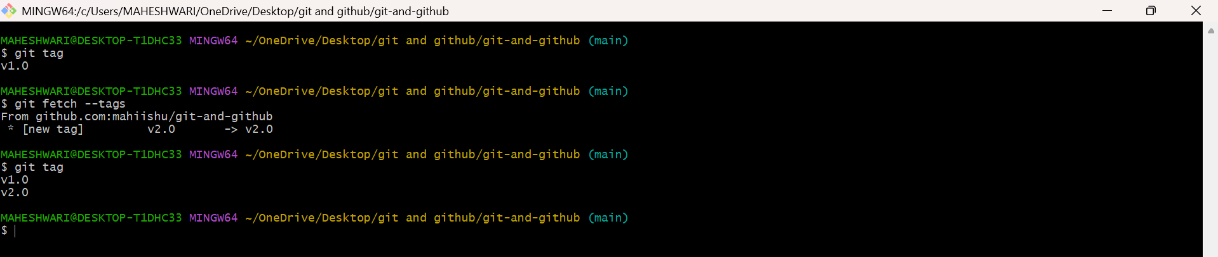

9.Git Config and Info (Configuration and repository information)
PURPOSE: used to manage configuration settings that control the behaviour of git. git config is to set, get or unset configuration values.
OBJECTIVE: git config command is used to set or retrieve configuration values that control git’s behaviour. Whereas git info command provides a summary of the current git configurations and status.

- git config --global user.name "Your Name": Sets your
global username for commits.
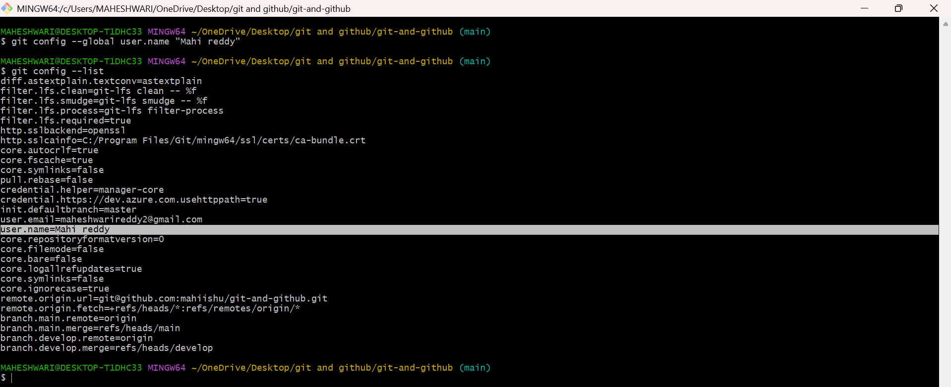
- git config --global user.email "youremail@example.com": Sets your global email for
commits.
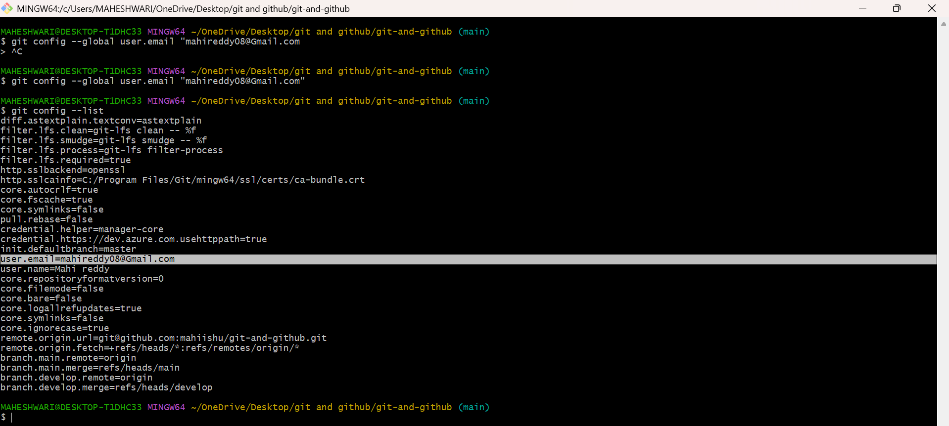
- git config --list: Lists all configuration settings.

- git config : Sets a specific configuration option.
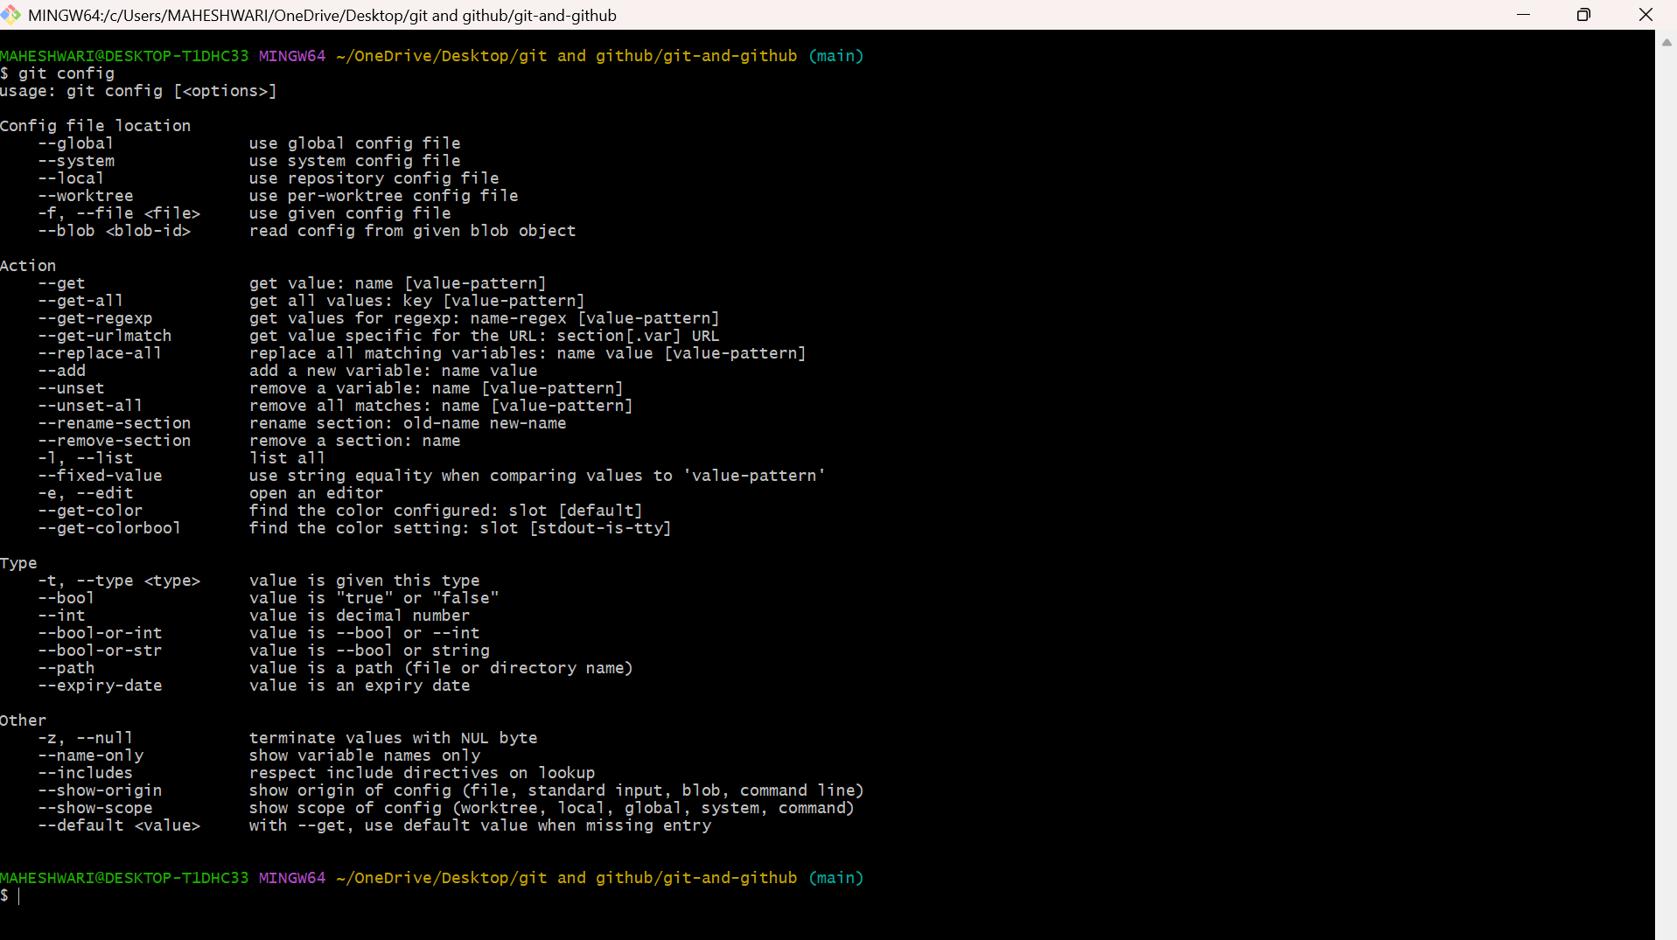
- git config --global core.editor : Sets the default text
editor for Git.
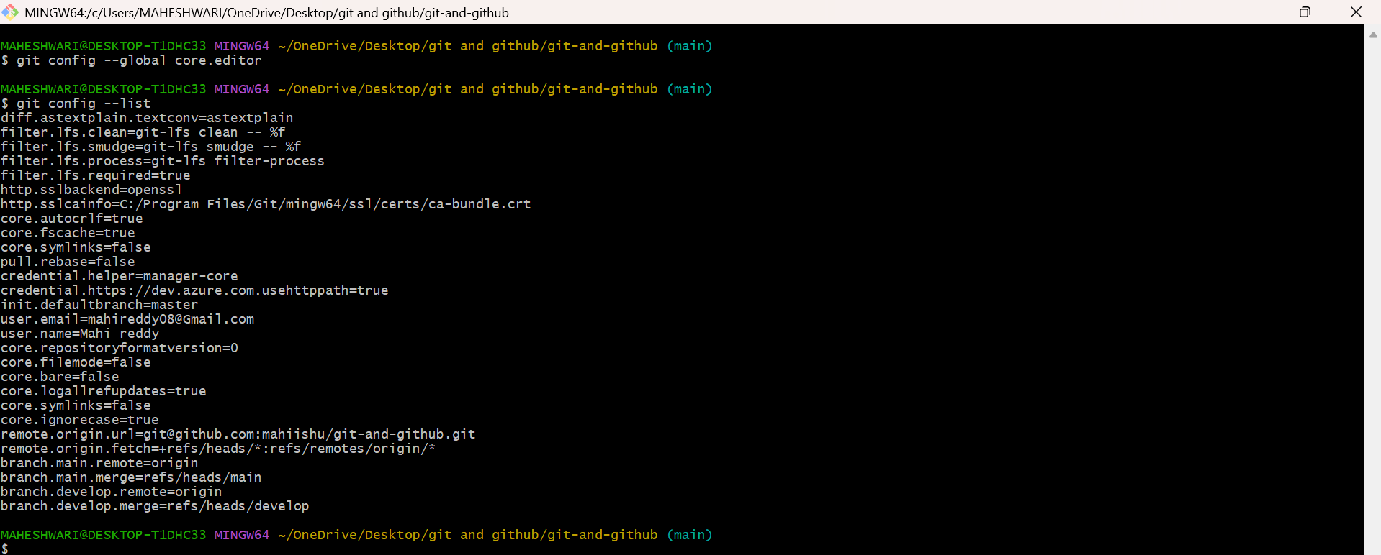
- git config --global color.ui true: Enables colored
output in Git.
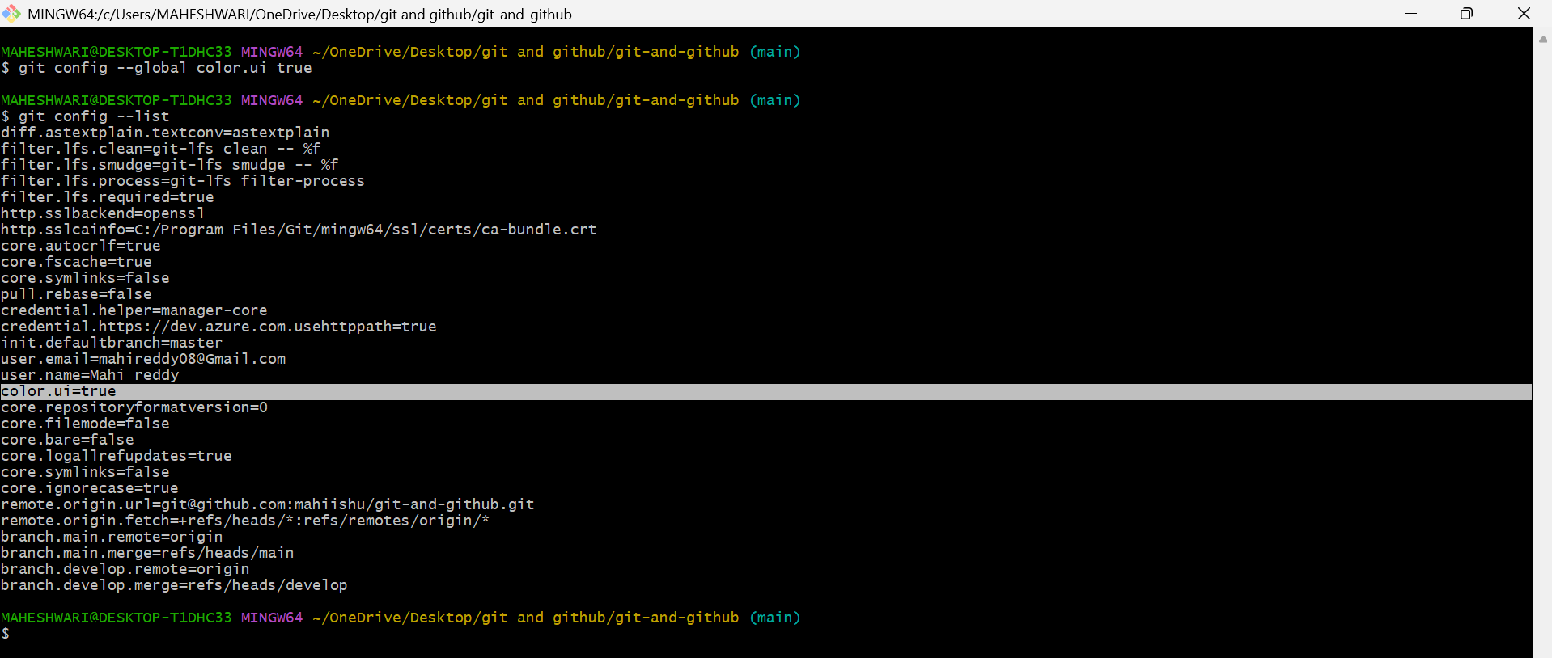
- git config --global alias.st status: Creates a custom
Git alias (e.g., git st for git status).
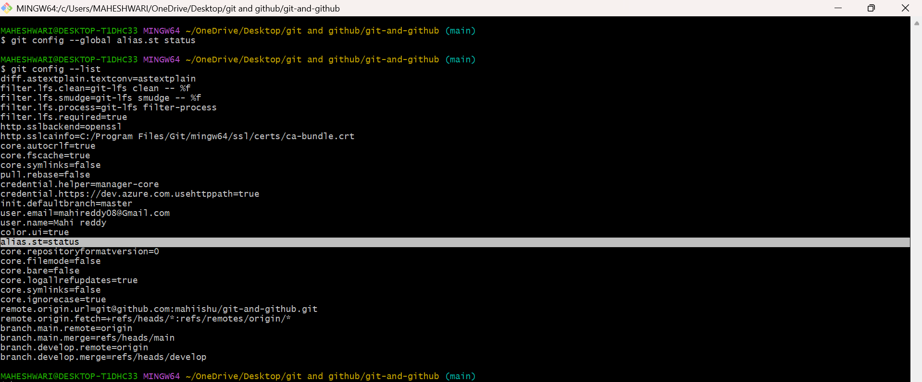

10. Git Aliases (Custom commands)
PURPOSE: git aliases are stored in configuration files, and their location depends on whether they are system-wide, global or local
1.system-wide aliases: stored in /etc/gitconfig file
2.global aliases : stored in the users home directory ~/.gitconfig file
3.local aliases: stored in the .git/config file
OBJECTIVE: You can configure git aliases to execute multiple commands in sequence, making repetitive workflows faster
- git config --global alias.<alias_name>
<actual_command>: Creates a new Git alias for an existing command.
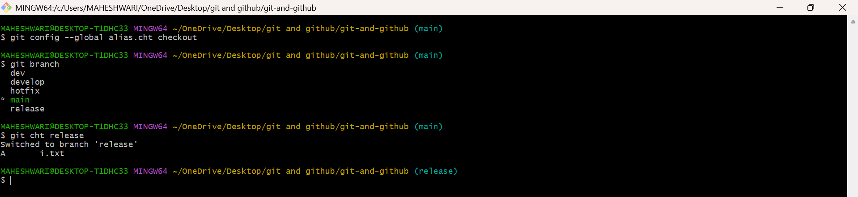

11. Git Hooks (Automated scripts triggered by Git actions)
PURPOSE: git hooks are scripts that run automatically before or after specific git events such as committing, pushing or merging. By default, hooks are stored in the .git/hooks directory, which is not tracked by the version control.
- git init: Creates a .git/hooks directory, where hook scripts are stored.
- git commit-msg: A hook that runs before a commit message is saved (you can use this to enforce message formats).
- git pre-commit: A hook that runs before a commit is made (can be used for checks like linting).
- git post-commit: A hook that runs after a commit is made.

